**CS551 Advanced Software Engineering**

**(Spring 2014)**

**Group #4**

**OCCASIONS ON THE GO**

**Instructor: Dr. Yugyung Lee Anudeep Vattipalli**

**TA: Feichen Shen Poojitha Mittapally**

**Prathyusha Dinne**

**Table of Contents**

|  |  |  |
| --- | --- | --- |
| **S.no** | **Description** | **Page No** |
| **1.** | **Project Proposal** | **3** |
| **2.** | **Project Plan** | **5** |
| **3.** | **First Increment** | **14** |
| **4.** | **Second Increment** | **23** |
| **5.** | **Third Increment** | **44** |
| **6.** | **Fourth Increment** | **56** |
| **7.** | **User Manual** | **63** |
| **8.** | **Final Project Evaluation** | **66** |
| **9.** | **Presentation Materials** | **67** |

**Project Proposal**

1. **Introduction:**

Occasions on the Go is an online based application that provides service to the customers in order to plan an event effectively. This application acts as a bridge between the users and the organizers in scheduling and conducting various events. It allows the customers to select any particular service that is available and suits the best for the occasion. The customers will be able to order the services from different vendors in the nearest locations.

1. **Project Goal & Objectives:**

**Overall Goal:**

The ultimate goal of the project is to design an online event organizer system through web and mobile app in order to provide customers the best services from different vendors. There are many vendors available for an event to arrange services like venue, food, decorations, and photography. It is very difficult to access various vendor’s information in order to get the best service of all. Also, identifying the vendors in the nearest locations and getting their reviews is very tough. To overcome these problems, our application provides the customers the option to choose vendors suitable to their requirements in the nearby proximity and place the order well in advance through online.

**Specific Objectives (Problem Statement):**

All the restaurants will have their own food ordering system and it is very difficult to access various restaurants and their menus to choose from. Even knowing & choosing the restaurants in the proximity is also tough. It is also tough to compare two restaurants and their reviews. If there is a daily order it is very tough to visit the site and place the order every day. In our system the customers can choose the restaurants in the nearby proximity and place the order from the portal. They can even place the order for the coming week or month in advance.

**Significance:**

The main significant feature of this project is customers need not visit each vendor’s website individually to know their features, deals or reviews. Instead, they can just register and login to our web application and choose the best vendors and their deals in nearby locations. They can also check the vendor’s previous events and their reviews posted on our website. Also, the user interface will be universal for all the vendors so that the customers can easily access this web application. The event organizer system will be a flexible and user friendly application. It gives the customers the choice of opting best vendors from the proximity and allows them to select the services like venue of the event, decoration, arrange the catering facility and photographer.

**Project Plan**

1. **Introduction:**

***Occasions on the Go*** is an online based application that provides service to the customers in order to plan an event effectively. This application acts as a bridge between the users and the organizers in scheduling and conducting various events. It allows the customers to select any particular service that is available and suits the best for the occasion. The customers will be able to order the services from different vendors in the nearest locations.

1. **Project Goal and Objectives:**

The ultimate goal of the project is to design an online event organizer system through web and mobile app in order to provide customers the best services from different vendors.

There are many vendors available for an event to arrange services like venue, food, decorations, and photography. It is very difficult to access various vendors’ information in order to get the best service of all. Also, identifying the vendors in the nearest locations and getting their reviews is very tough. To overcome these problems, our application provides the customers the option to choose vendors suitable to their requirements in the nearby proximity and place the order well in advance through online.

**Significance:**

The main significant feature of this project is customers need not visit each vendor’s website individually to know their features, deals or reviews. Instead, they can just register and login to our web application and choose the best vendors and their deals in nearby locations. They can also check the vendor’s previous events and their reviews posted on our website. Also, the user interface will be universal for all the vendors so that the customers can easily access this web application. The event organizer system will be a flexible and user friendly application. It gives the customers the choice of opting best vendors from the proximity and allows them to select the services like venue of the event, decoration, arrange the catering facility and photographer.

1. **Project Background and Related Work:**

We find a number of websites having their own online ordering service like <http://www.unionhillinn.com>. In this portal, the users have the facility to search venue, catering by place and prices. Users have the option to choose the best service in the required location and book for the specified time. Currently, we find no such online service providing these services across various vendors. Our project will be solution for this.

1. **Proposed System:**
2. **Requirement Specification:**

**Functional Requirements (Prioritized):**

* Users can register with their details, login and then update their profile if required.
* Vendor Managers can also register with their details, login and update their options.
* Customers can choose the vendors in the near proximity and place the order in advance.
* Navigation to the selected place was provided to the customers.
* Mail sent to vendor manager after order was placed by customer.

**Non Functional Requirements:**

* Our online service will be available on every day i.e., 24*7
* Online web application needs to be User Interface rich with the usage of minimum bandwidth for loading of the page.

**Business Process/Workflow Analysis:**

* Vendor Managers registers, login and will post their offers.
* Users register, login, selects each of the services and would be asked to search for different vendors. Then the vendors in the near proximity will be displayed.
* After choosing a vendor, user will be provided options to “view details” or “place order”
* If customer opts to “view details”, vendor’s past event details will be displayed.
* If customer opts to “place order”, he would be mainly asked for the date and time to book the slot. Also, further details need to be filled in order to complete the ordering procedure.
* Once the order was placed, a mail with order details and user address will be mailed to vendor manager. Also, an order confirmation mail will be send to user for the same.

**Technological Requirements:**

* **ASP.NET:** It is a server side framework designed to build dynamic web applications. This was developed by Microsoft in order to produce dynamic web services.
* **C#:** This is object-oriented language used in building very secure and robust applications.
* **JAVA:** It is a programming language used to create applications on single or distributed systems among clients and servers on a network.
* **SOAP Web Service:**  It is a architectural style that indicates uniform interface in order to enable services to apply best to Web**.**

1. **Framework Specification: Build an overall system model**

* **Methodologies and Algorithms:**

Scrum is one of the important agile methodologies which will be followed in our project. Project requirements can change frequently in order make the web application more creative. Here is where, scrum will be the best methodology to suit for our project. In Agile, project is developed as part of increments wherein each increment is expected to provide a working outcome.

1. **System Specification: Identify Primary Services**

* **Existing Services:**

|  |  |  |  |
| --- | --- | --- | --- |
| **S.no** | **Name** | **Description** | **URL** |
| 1 | Google Maps | To get directions to the vendor from user location | https://maps.googleapis.com/maps/api/directions/output?parameters |
| 2 | Twitter API | To share vendor details/ comments in twitter profile | <https://twitter.com/share> where class=”share-button” and data-lang=”en” |
| 3 | Google Search Engine | To search for vendor by name or location | https://ajax.googleapis.com/ajax/services/searc  h/web?v=1.0&q= |

* **New Services to be built:**

**Login:** To authenticate customer and vendor manager login.

**Update-user:** To update the user profile.

**Update-vendor:** To update the vendor profile, services, offers and prices.

**Retrieve:** Depending on customer search criteria, we get the data.

**Class Diagram:**

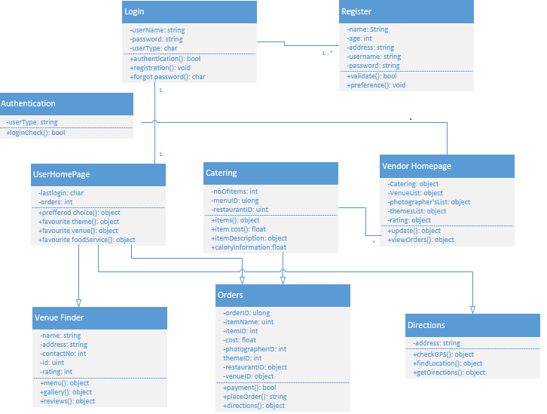

**Sequence Diagram for Customer:**

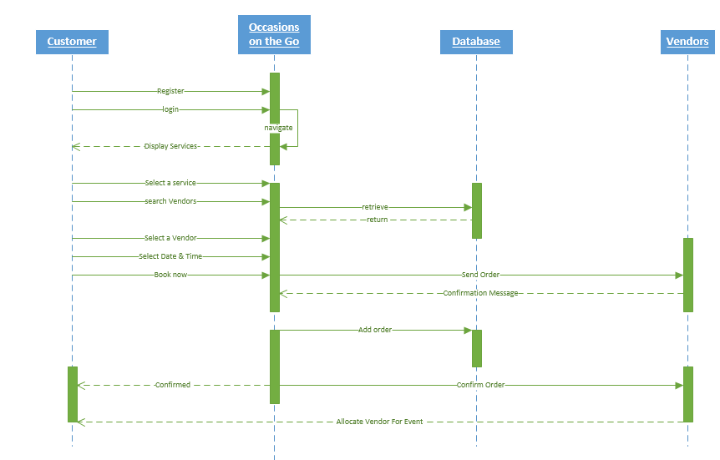

**Sequence Diagram for Vendor:**

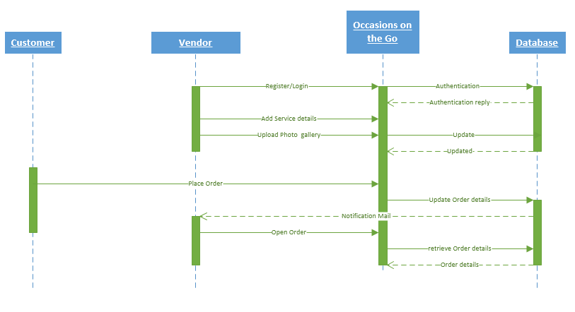

**Activity Diagram:**

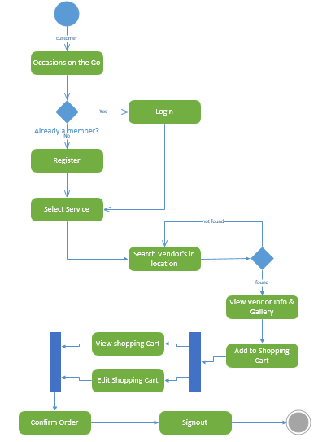

**Service Specification:**

* **Operational Description:**

*Vendor Manager:* Logins to our web application, create new offers/services and updates the existing prices and contact information.

*Customer:* Logins to our web application, searches for different vendors and places the order depending upon the requirement.

* **Input/output:**

Input is the vendor name or location given by user and output will be results searched from the database that matches with the user input.

* **Actors/Objects:**

There are total of three actors in our project. They are Customer/User, Vendor Manager and Administrator.

**Design of Mobile Client:**

* **Features:**
* Allows user and vendors to register, login and view/update their details.
* Users have the option to search for vendors in nearest location and place order depending on their requirement
* A confirmation mail will be sent to both user and vendor after the order is placed.
* **Technologies**: JAVA, C#, ASP.NET, SOAP Web Service

1. **Plan by Services:**

We have planned to implement our project in four increments.

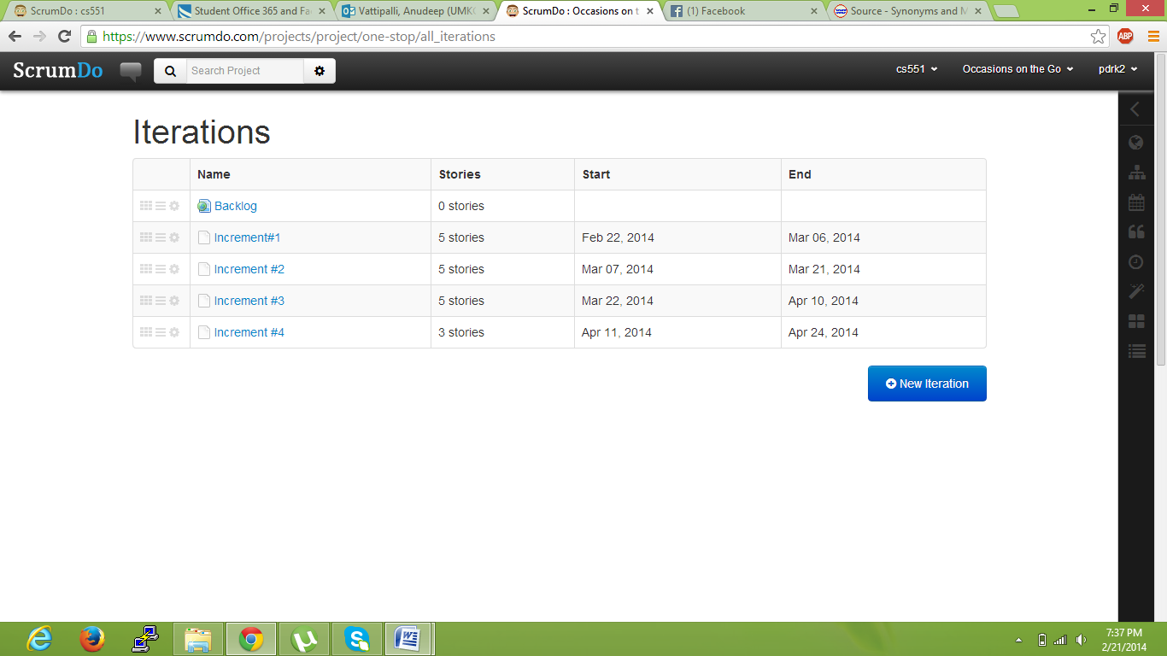

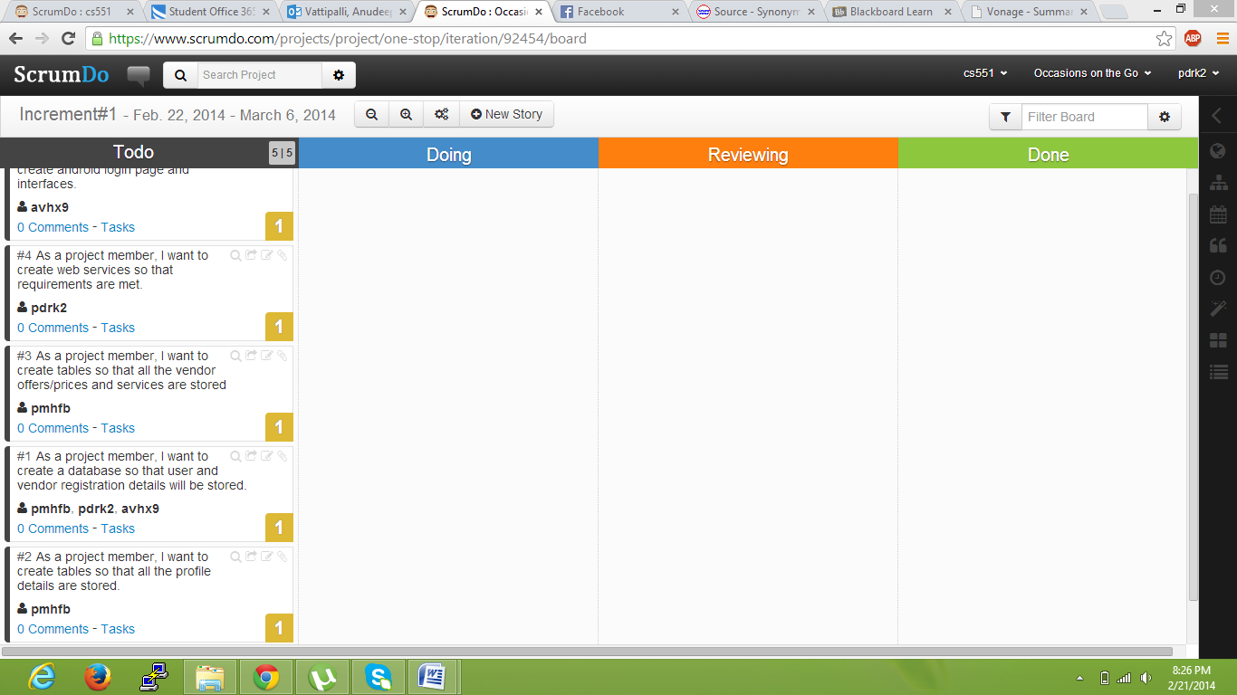

**Responsibilities:**

* **Database:** Poojitha Mittapally
* **UI:** Anudeep Vattipalli
* **Android:** Prathyusha Dinne
* **C#:** Poojitha, Anudeep
* **Testing C#:** Anudeep
* **Testing Android:** Poojitha, Prathyusha

The roles may differ depending on the evolution of the increments and projects.

1. **Risk Management:**

* To process multiple transactions with no interruptions.
* Login authentication both in mobile client and web applications need to be right to avoid third parties accessing this website.
* Mail service need to fast and reliable.
* Vendor’s information need to be up to date in the portal to avoid inconvenience for users.

**First Increment**

**Introduction:**

Planning an event is very simple and is on high demand. To plan an event, you need to select every vendor, login to their websites and order the required services. Also, it will be difficult to adapt to different patterns and designs as each vendor has their own in built design. To avoid these problems, our project acts as a single stop where in user can find different vendors in one place with a common user interface (UI). This project provides feasibility to order services both through mobile and web applications. In this application, both users and vendors can take advantage as user will be provided with best deals and vendor can attract customers by giving offers.

**Work Completed till 1st Increment:**

We have created both web pages for user and vendor registration, login authentication and profile updates. Same functionality pages were implemented even in android.

**Implementation Status Report:**

**Work Completed:**

Database plays a vital role in the project. So, for the first increment we have created few tables in the databases. The tables which we have created were:

* User details
* Vendor Details

**User Details Table:**

This table consists of attributes username, password, email, contact number and zipcode.

Queries used on these tables were:

1. Insert into table registration values (name, password, email, contactno, zipcode). These values are picked from the end user feed.
2. Select name, email, contactno, zipcode from registration where name=’username’ and password=’pass’
3. Update registration (username=name, email=email, contactno=contactno, zipcode=zip)

**Vendor Details Table:**

This table consists of attributes vendor name, password, email, contact number and zipcode.

Queries used on these tables were:

1. Insert into table vendor values (name, password, email, contactno, zipcode). These values are picked from the end vendor feed.
2. Select name, email, contactno, zipcode from vendor where name=vendorname and password=’pass’
3. Update vendor (vendorname=name, email=email, contactno=contactno, zipcode=zip)

**Implementation of Services :**

Below services developed as part of this increment is:

1. Facebook API
2. Twitter API

As part of user interface, we have implemented sliding of images on the web pages for effective web page view.

**Screenshots of Web Application:**

**Home Page:**

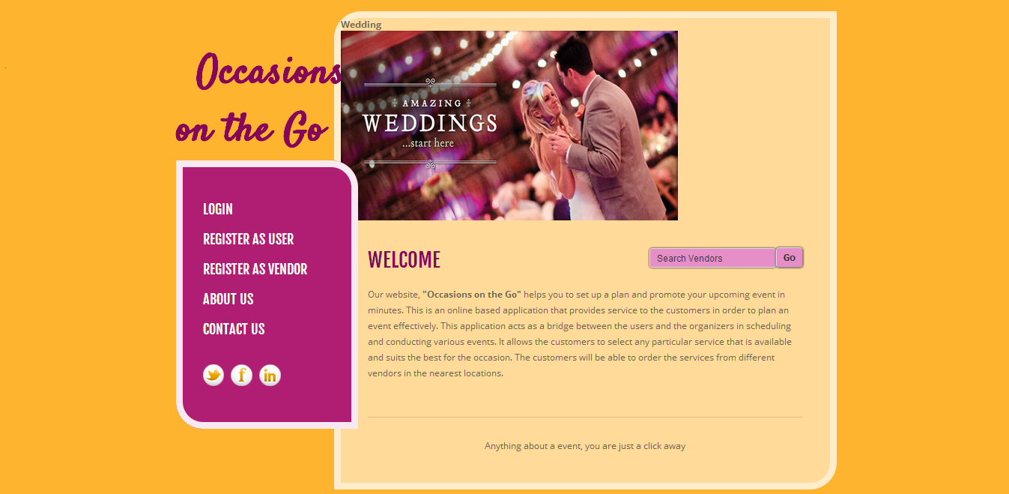

**Login Page:**

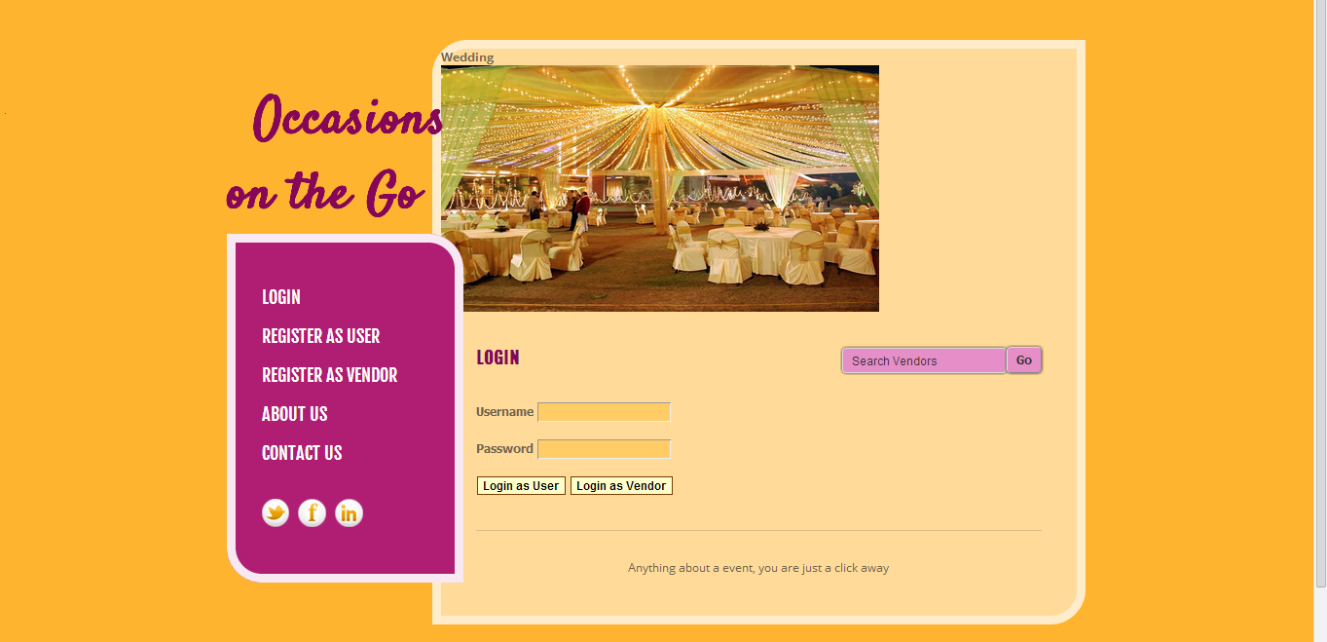

**User Registration Page:**

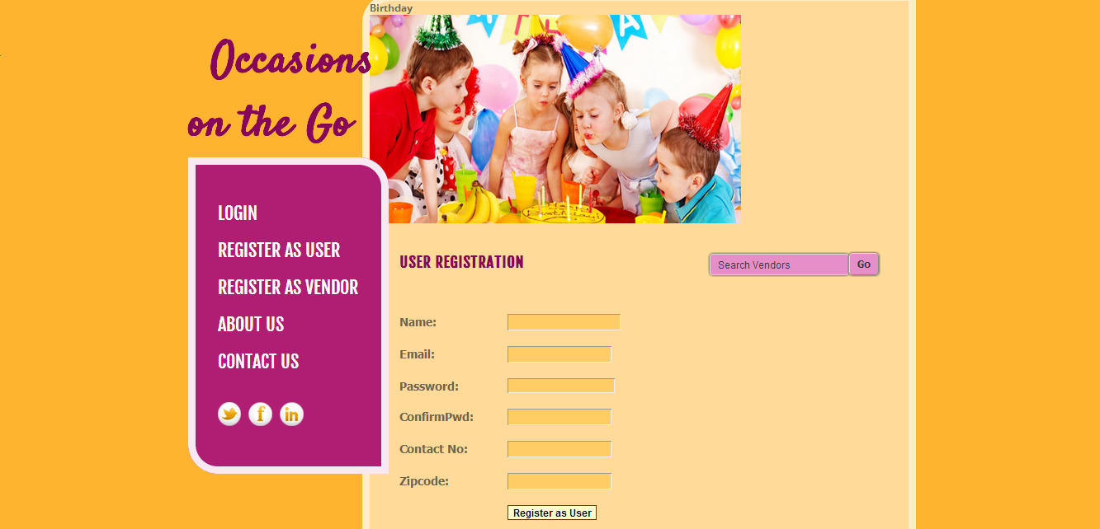

**Vendor Registration Page:**

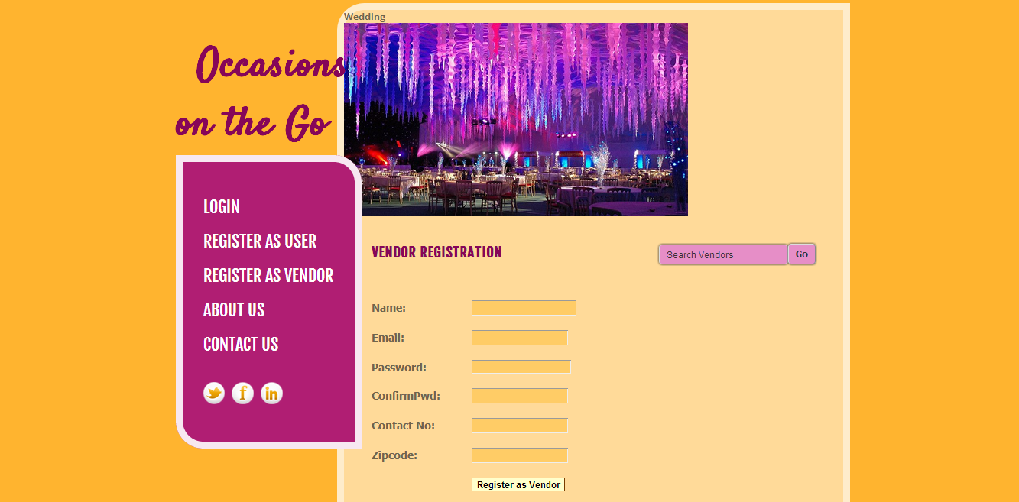

**Android Login Page:**

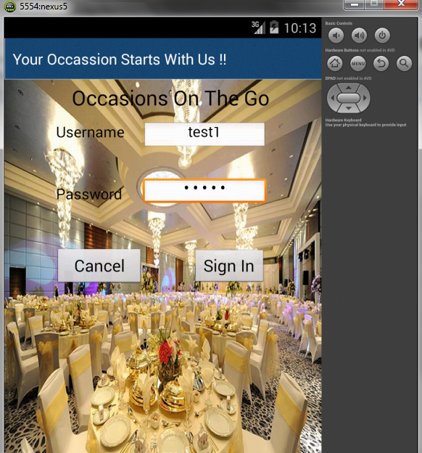

**Android Page after login page:**

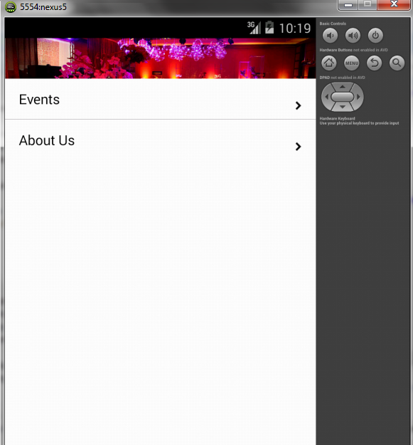

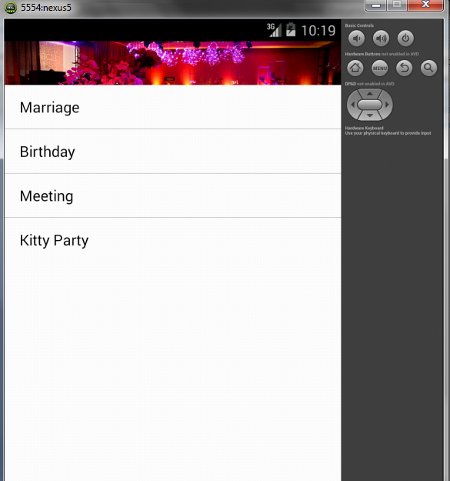

**Responsibilities:**

|  |  |  |  |
| --- | --- | --- | --- |
| **Sl.No** | **Task** | **Person involved** | **Estimated Time** |
| 1. | Designed UI for both web and android application | Prathyusha  Anudeep | 3 hr |
| 2. | Database creation and connection using sql management studio to store user and vendor details | Prathyusha  Anudeep  Poojitha | 1 hr |
| 3. | Create tables to store user details | Poojitha | 2hr |
| 4. | Create sessions to maintain the login details | Prathyusha  Poojitha  Anudeep | 2hr |
| 5. | Create tables to store vendor details | Poojitha | 2hr |
| 6. | API services | Prathyusha | 2 hr |
| 7. | To create android login and home pages | Anudeep | 2hr |
| 8. | Testing | Prathyusha  Anudeep  Poojitha | 2hr |

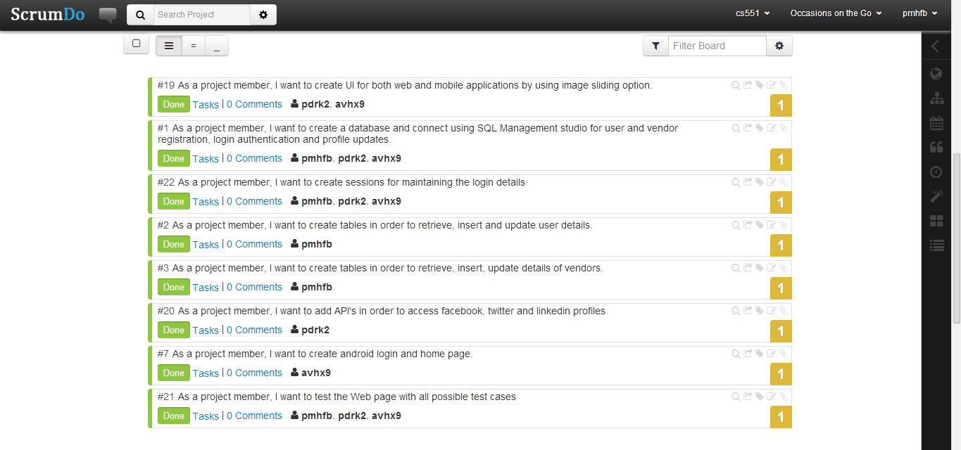

**Work To Be Completed As Part Of 2nd Increment:**

We will be implementing the web services in second increment and link it to database for the search engine and then create a page to display the search results.

**Responsibilities:**

|  |  |  |
| --- | --- | --- |
| **Sl.No** | **Task** | **Person involved** |
| 1. | To create web services for google and facebook | Prathyusha  Anudeep  Poojitha |
| 2. | To create web services for searching the vendor | Prathyusha  Anudeep  Poojitha |
| 3. | To implement web services on android. | Prathyusha  Anudeep  Poojitha |
| 4. | Implementing shopping cart page | Prathyusha  Anudeep  Poojitha |
| 5. | Testing web services using Nunit testing | Prathyusha  Anudeep  Poojitha |
| 6. | Documentation work | Prathyusha  Anudeep  Poojitha |

**Second Increment**

**Introduction:**

Planning an event is very simple and is on high demand. To plan an event, you need to select every vendor, login to their websites and order the required services. Also, it will be difficult to adapt to different patterns and designs as each vendor has their own in built design. To avoid these problems, our project acts as a single stop where in user can find different vendors in one place with a common user interface (UI). This project provides feasibility to order services both through mobile and web applications. In this application, both users and vendors can take advantage as user will be provided with best deals and vendor can attract customers by giving offers.

**Implementation Status Report:**

**Work Completed till 2nd Increment:**

In second increment, along with the 1st increment development we designed web services for search, categories, menu listing. We have also created web services for the registration and login of vendor and user. Below pages were developed in second increment.

* Profile page for all vendors (Photography, Venue, Catering and Theme) .
* Display page for all vendors
* Menus and Services page for all vendors
* Menus and Services edit pages for all vendors.
* Profile editing page for all vendors.
* Developed web service to retrieve login information and to register.
* Developed web service to retrieve menu items of all vendors.
* Profile editing pages for the users
* Vendors place will be shown on Google map
* User can add the items to the shopping cart
* User can view and remove the items from shopping cart

**Web Services:**

The web services which we developed were:

1. Login web service
2. Vendor menus
3. Item find

Login web services have the following methods:

1. User and vendor Login check
2. User profile update
3. Vendor profile update
4. Vendor Profile retrieval
5. User Profile retrieval
6. User registration
7. Vendor registration

Vendor Menu and Item find web service has the following methods:

1. Adding Menu items (for Catering and Theme Vendors )
2. Editing Menu items
3. Retrieval of menu items
4. Adding services for vendors (for Photography and Venue Vendors)
5. Editing services for vendors

**Item Menus Table:**

This table consists of all the items and their details for each and every vendor. All details like item name and description will be saved along with the item type and item price.

Queries Used for this table were:

a) Insert into items_menus values( item_name , item_price, item_desc, item_type, vendor_name)

b) Update into items_menus values( item_name, item_price, item_type, item_desc where vendor_name =”xxx”)

c) Select * from item_menus where vendor_name=”xxx”

**Implementation of Services :**

Below services developed as part of this increment is:

1. Google Map services
2. Shopping Cart services

As part of user interface, we have implemented sliding of images on the web pages for effective web page view.

**Screenshots of Web Application:**

**Home Page:**

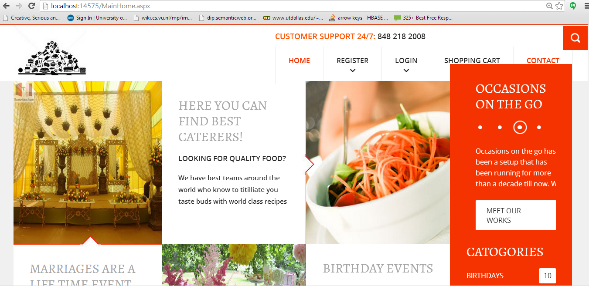

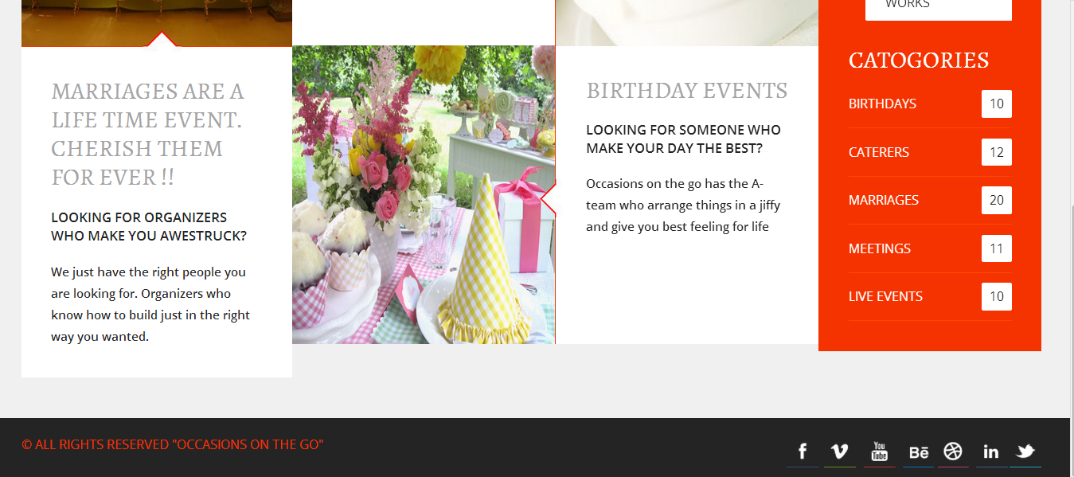

**Login Page:**

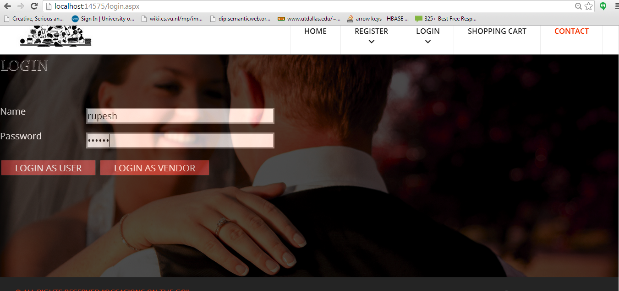

**User Profile:** After login the user is redirected to below screen with options of editing his user details and also to choose among list of available services as below.

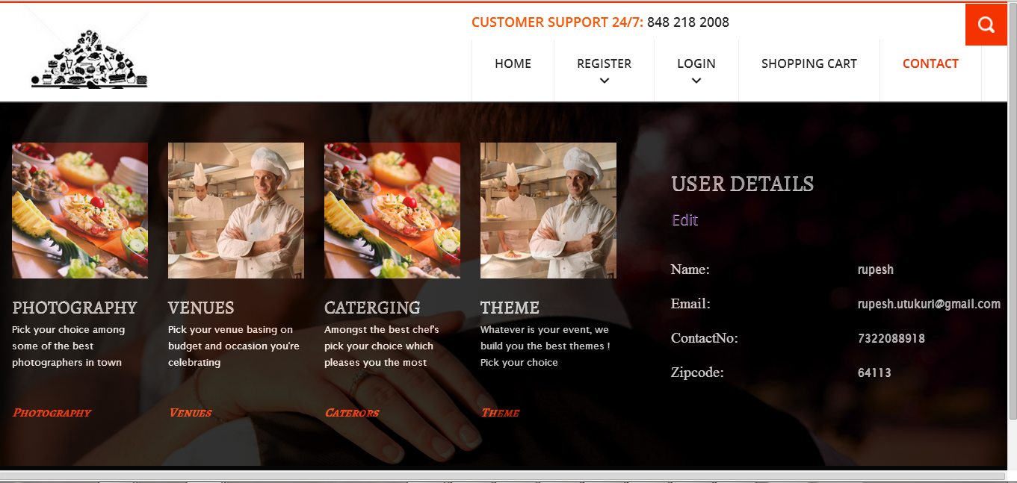

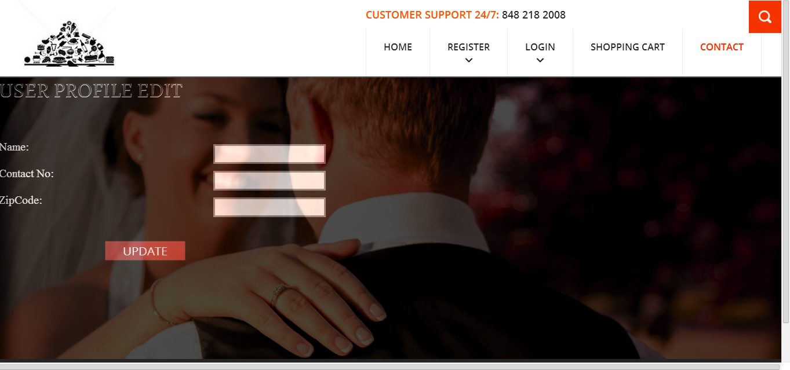

**Vendor Display:** Below screen shows vendor details of different vendors to user, where one can choose different options available.

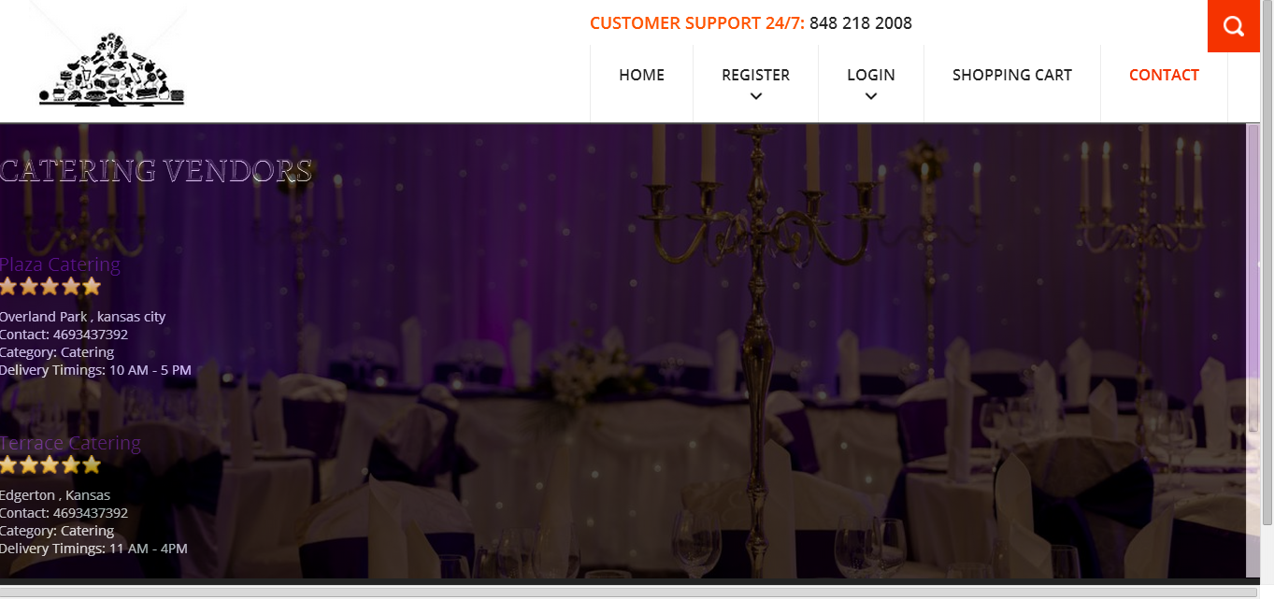

**Vendor single:** Below screens show individual vendor details, contact information and location through google map services.

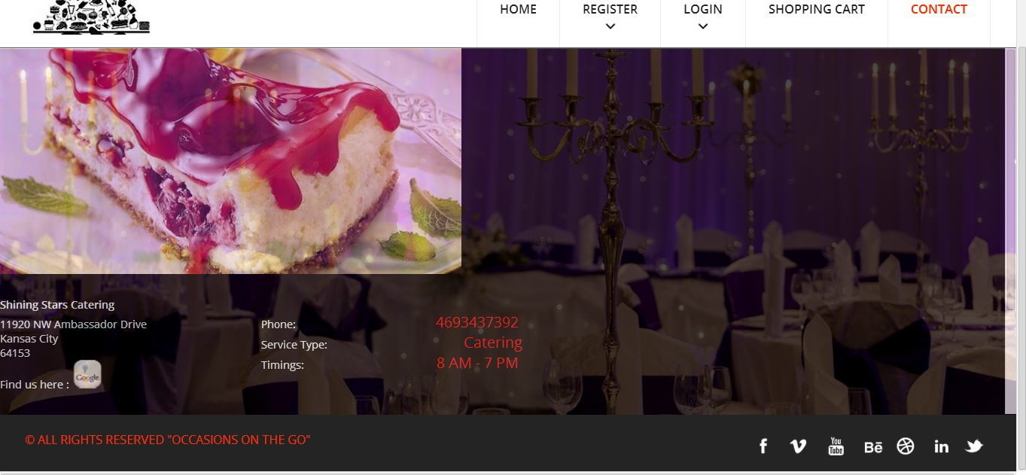

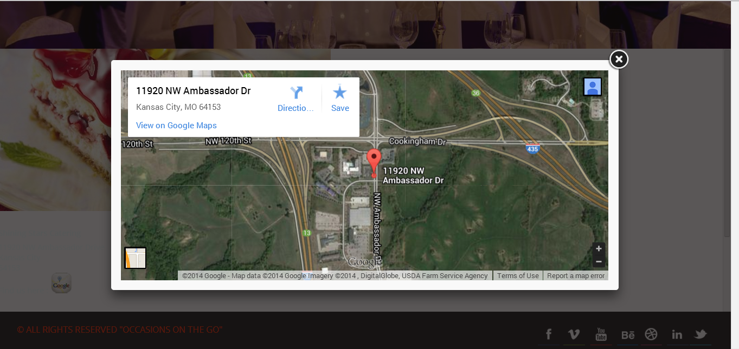

**Menu Display:** Below screen consists of different eatable items and prices with option of adding them to cart.

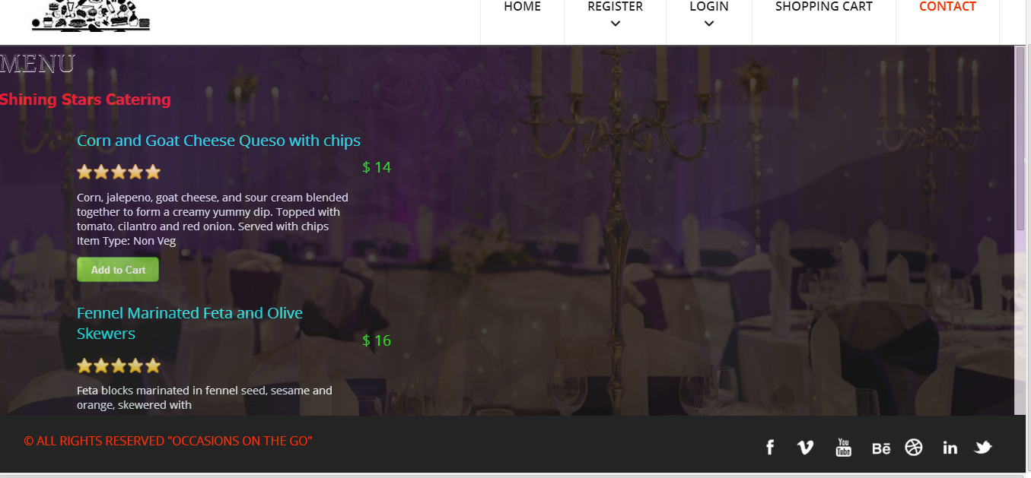

**Shopping cart:** All the items added to cart are displayed in the shopping cart page with sub total of all the items and check out option.

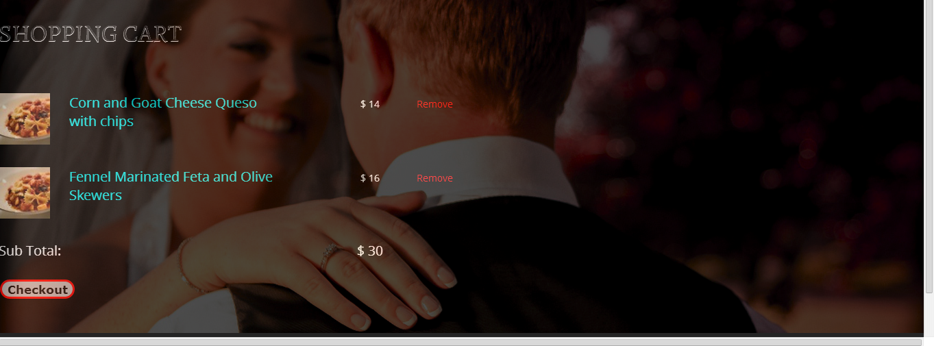

**Vendor Display:** Photography services



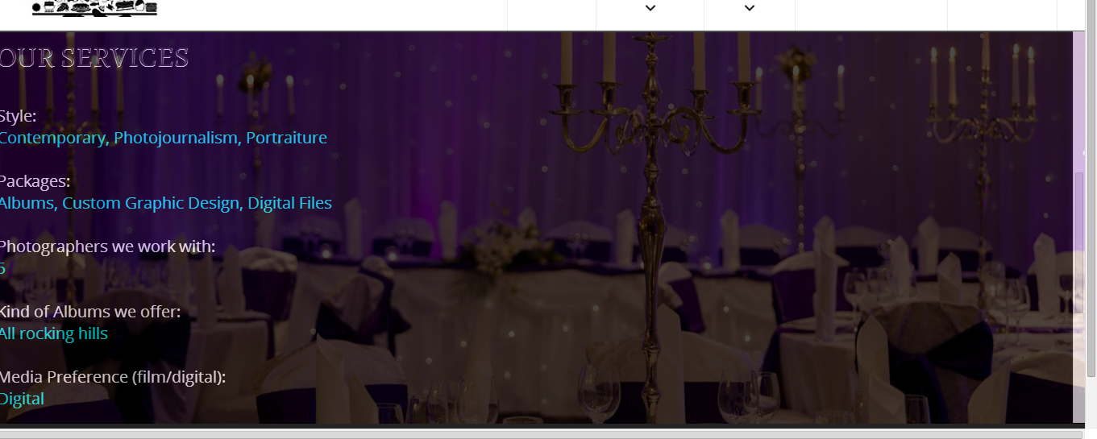

**Register As Vendor:** Vendor login page different from customer login page.

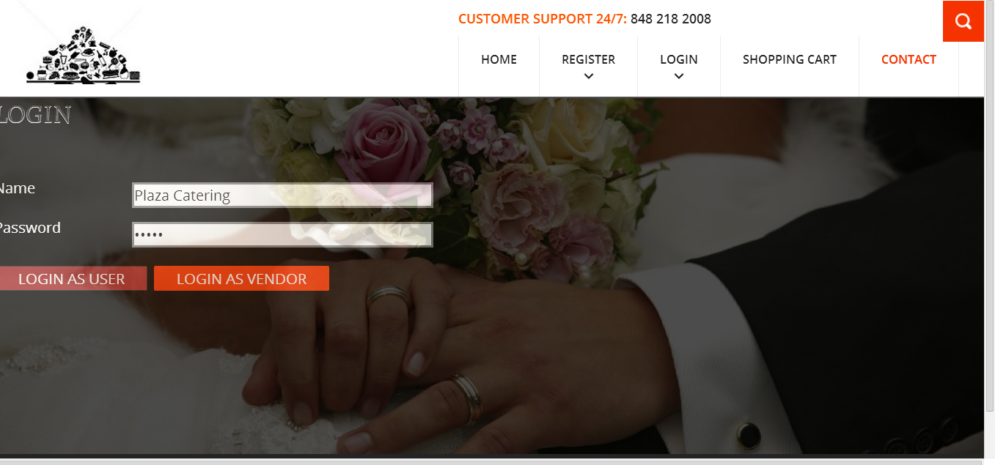

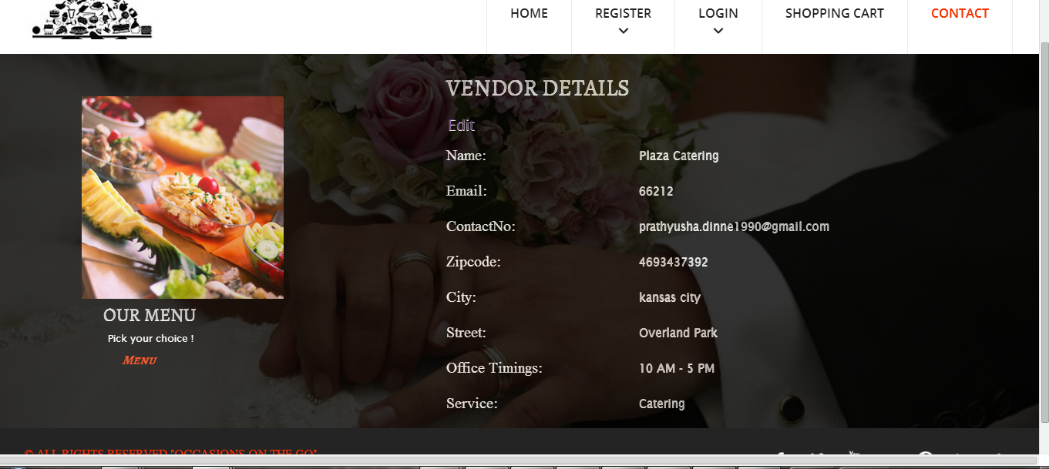

**Menu Display:** Vendor details are displayed in the below screen.

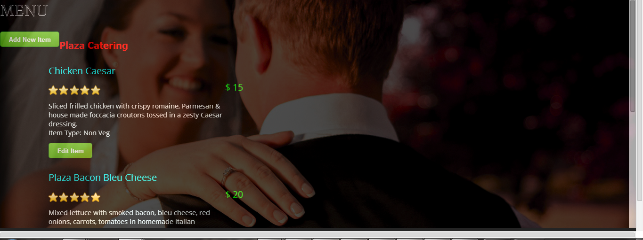

**Photo_ Menu:**

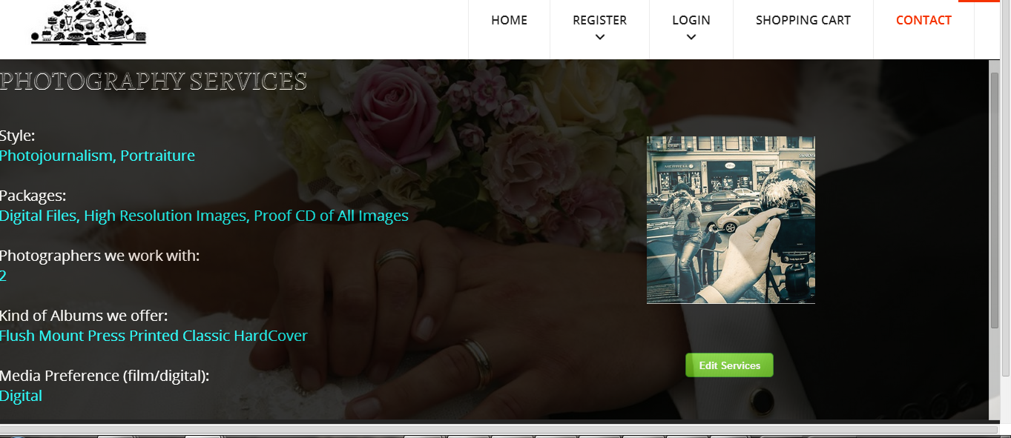

**Database tables:**

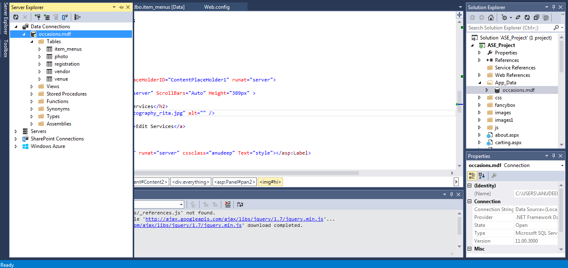

**Android App Screenshots:**

**Login Page:**

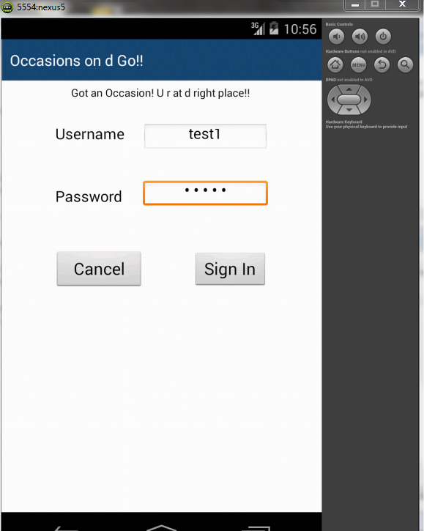

**Home Screen:**

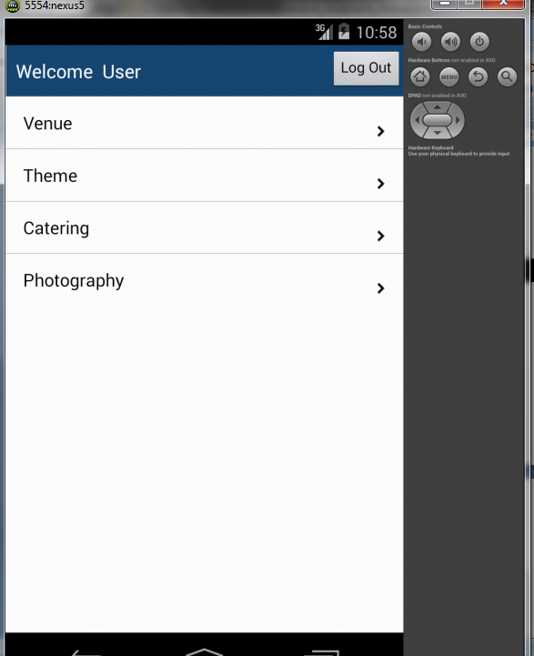

**Catering:**

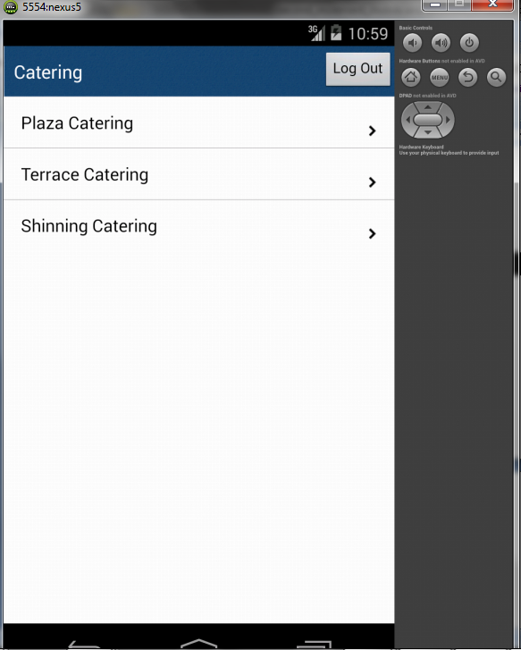

**Plaza Catering Contact:**

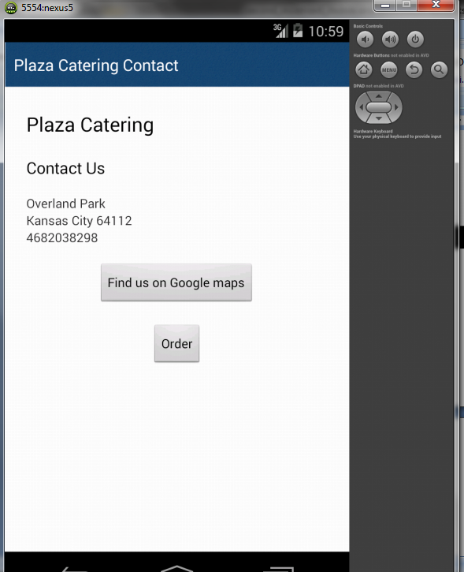

**Catering Menu:**

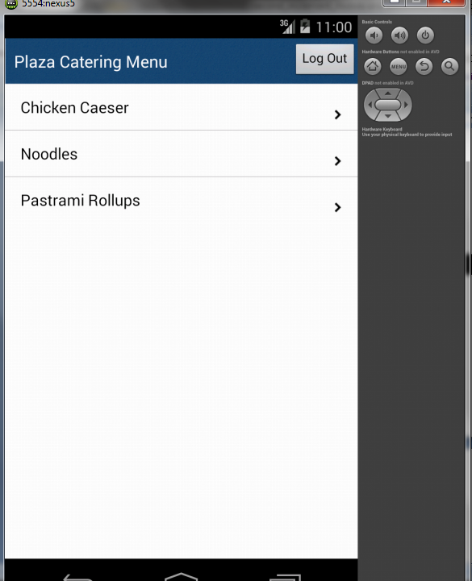

**Item Description Page:**

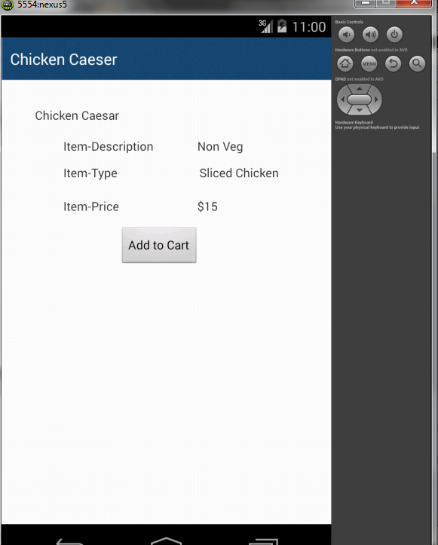

**Venue Description Page:**

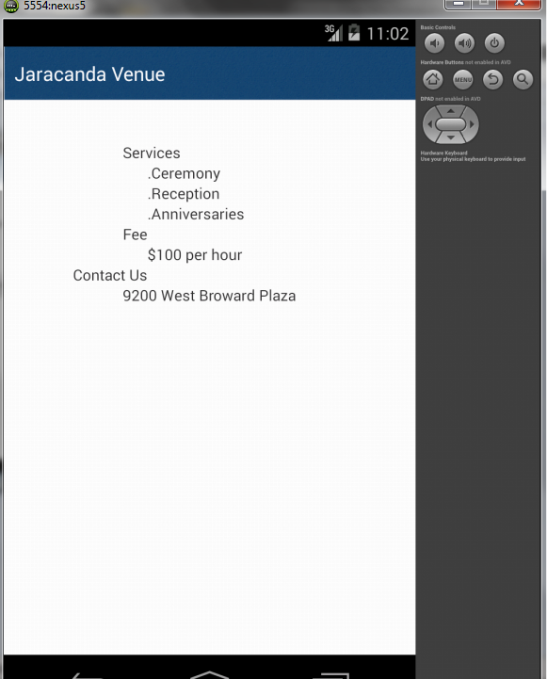

**Work Completed As Part Of 2nd Increment:**

We implemented the web services in second increment and linked it to database.

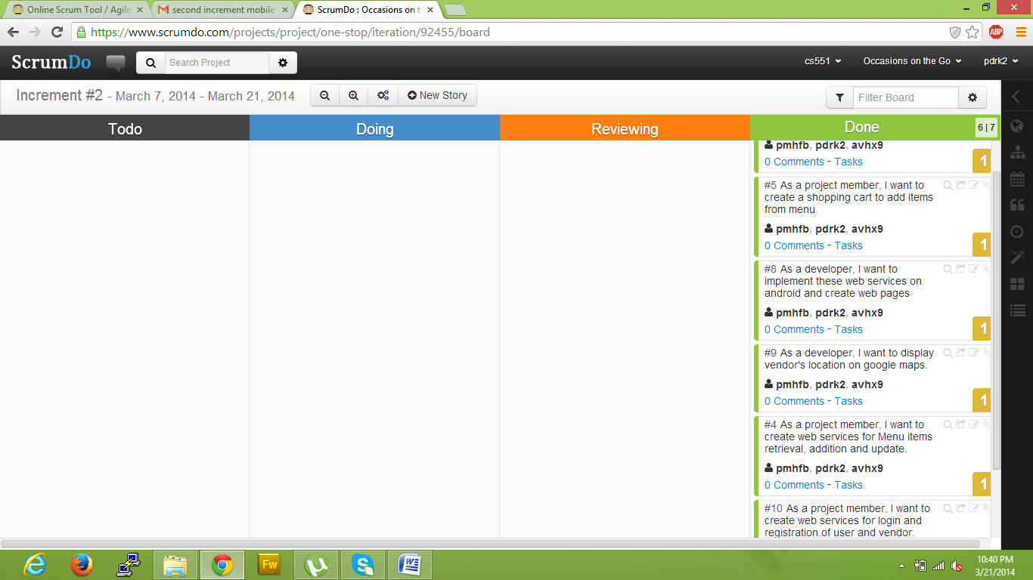

**Responsibilities:**

|  |  |  |  |
| --- | --- | --- | --- |
| **Sl.No** | **Task** | **Person involved** | **Estimated Time** |
| 1. | Created web services for login and registration of user and vendor. | Prathyusha  Anudeep  Poojitha | 8 hours |
| 2. | Created web services for Menu items retrieval, addition and update. | Prathyusha  Anudeep  Poojitha | 6 hours |
| 3. | Display of vendor’s location on Google map | Prathyusha  Anudeep  Poojitha | 2 hours |
| 4. | To implement web pages on android. | Prathyusha  Anudeep  Poojitha | 6 hours |
| 5. | Implemented shopping cart page | Prathyusha  Anudeep  Poojitha | 5 hours |
| 6. | Testing web services using Nunit testing | Prathyusha  Anudeep  Poojitha | 2 hours |
| 7. | Documentation work | Prathyusha  Anudeep  Poojitha | 2 hours |

**Work to be completed in 3rd increment:**

**Responsibilities:**

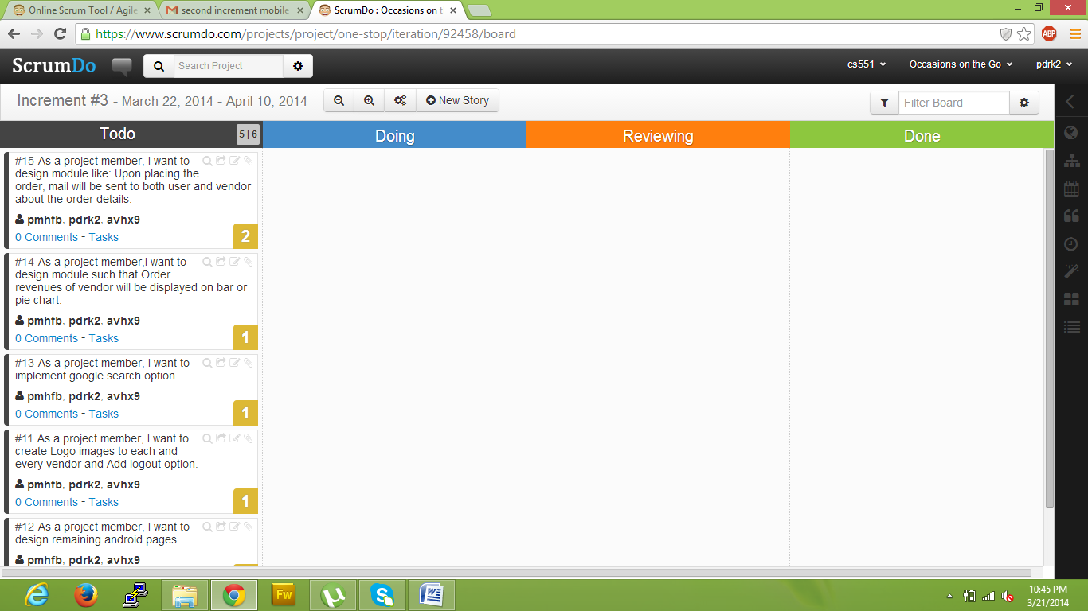

|  |  |  |
| --- | --- | --- |
| **Sl.No** | **Task** | **Person involved** |
| 1. | Upon placing the order, mail will be sent to both user and vendor about the order details. | Prathyusha  Anudeep |
| 2. | Order revenues of vendor will be displayed on bar or pie chart | Prathyusha  Anudeep  Poojitha |
| 3. | Implementing Google search engine option | Poojitha |
| 4. | Further enhancements to second increment will be implemented. | Prathyusha  Poojitha  Anudeep |
| 5. | Logo images to be inserted to each and every vendor. | Poojitha |
| 6. | Android web pages will be designed | Prathyusha |
| 7. | Testing | Anudeep |
| 8. | Documentation | Prathyusha  Anudeep  Poojitha |

**Third Increment**

**Introduction:**

Planning an event is very simple and is on high demand. To plan an event, you need to select every vendor, login to their websites and order the required services. Also, it will be difficult to adapt to different patterns and designs as each vendor has their own in built design. To avoid these problems, our project acts as a single stop where in user can find different vendors in one place with a common user interface (UI). This project provides feasibility to order services both through mobile and web applications. In this application, both users and vendors can take advantage as user will be provided with best deals and vendor can attract customers by giving offers.

**Implementation Status Report:**

**Work Completed till 3rd Increment:**

In third increment addition to what has been done in second increment, we have implemented search engine which allows users to search for content within the site. Other features which we have developed include delivery of mails to customers and vendors upon successful completion of order, checkout page consisting of all the orders, vendors can check for all the orders which are ordered by different customers and also vendors can view their monthly sale revenues through a bar chart graphical representation.

* Search Engine internal to our website for searching web content within the site
* Checkout page with all orders from the customer
* Graphical representation of monthly revenues of vendor sales
* Complete implementation of shopping cart
* SMTP mail client implementation
* Menus and Services edit pages for all vendors.
* Profile editing page for all vendors.
* Developed web service to retrieve login information and to register.
* Developed web service to retrieve menu items of all vendors.
* Profile editing pages for the users
* Vendors place will be shown on Google map
* User can add the items to the shopping cart
* User can view and remove the items from shopping cart

**Web Services:**

The web services which we developed were:

1. Order details
2. Vendor menus
3. Item find
4. Login web services

Order details web services have the following methods:

1. Adding user and vendor details respective to the order
2. Adding user order address details
3. User can view the orders
4. Vendor can view the orders

Vendor Menu and Item find web service has the following methods:

1. Adding Menu items (for Catering and Theme Vendors )
2. Editing Menu items
3. Retrieval of menu items
4. Adding services for vendors (for Photography and Venue Vendors)
5. Editing services for vendors
6. Search results to display the searching item

**Order Detials Table:**

This table consists of all queries Used for this table were:

a) insert into order_details (user_id,ven_id,details,total) values('" + user_id + "','" + ven_id + "','" + details + "','" + total + "');

b) UPDATE order_details SET email = '" + email + "', street = '" + street + "', city = '" + city + "', state = '" + state + "' , phone = '" + phone + "', date = '" + yDate + "' where id = '" + id + "'"

c) select * from order_details where ven_id = '" + ven_id + "'"

**Implementation of Services :**

Below services developed as part of this increment is:

1. Shopping Cart
2. Order of services for different vendors where vendors can view the order from customer to address them. And also customer can view their own orders
3. SMTP mail implementation, which is used to send mails to customers and vendors upon successful order of services.
4. Internal search engine to search the content of all data within our site
5. Vendors can view monthly revenue of sales through a bar graph

As part of user interface, we have implemented sliding of images on the web pages for effective web page view.

**Screenshots of Web Application:**

**User Profile:**

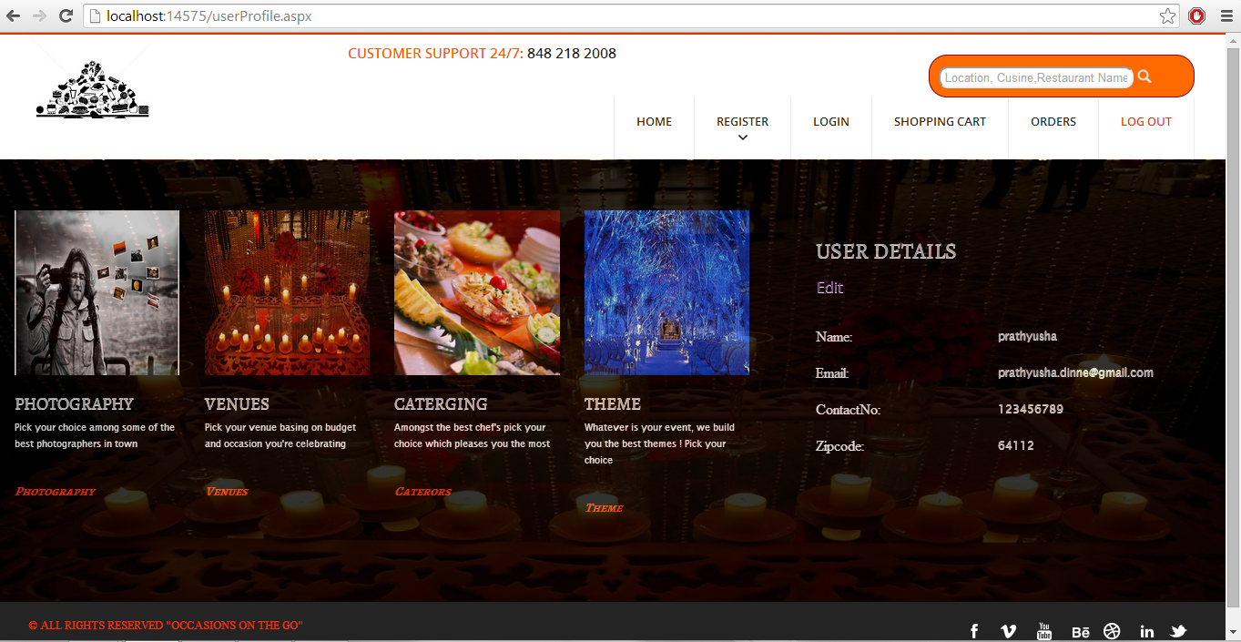

**Menu Display:**

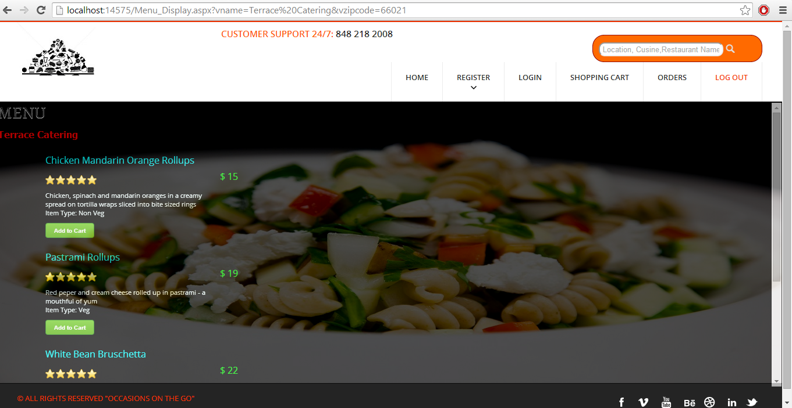

**Shopping Cart:**

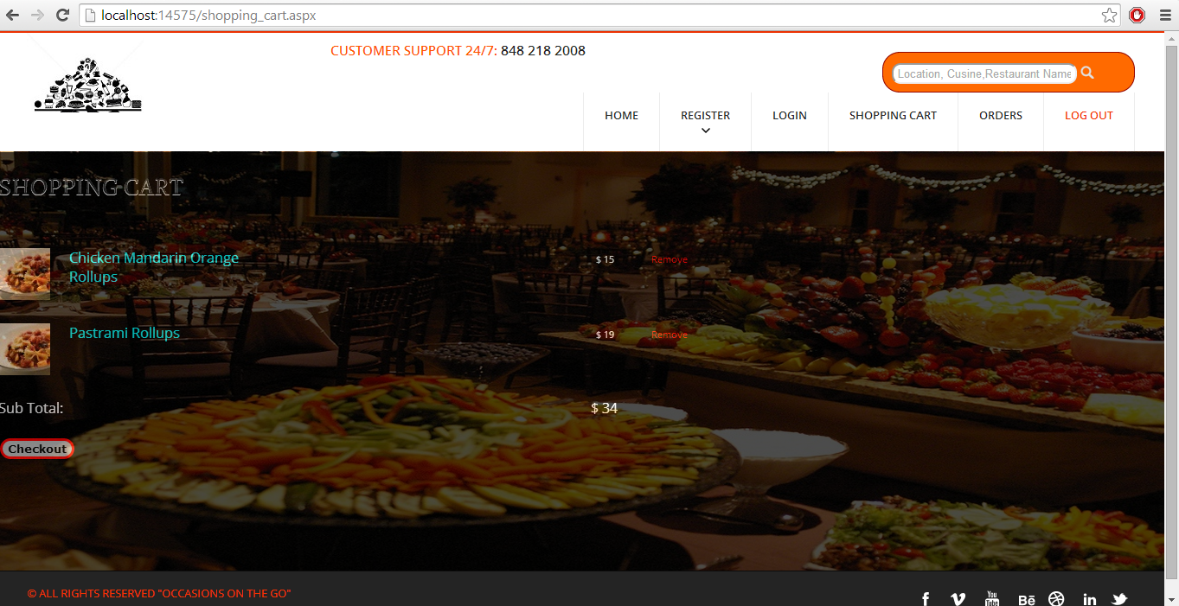

**Checkout Page:**

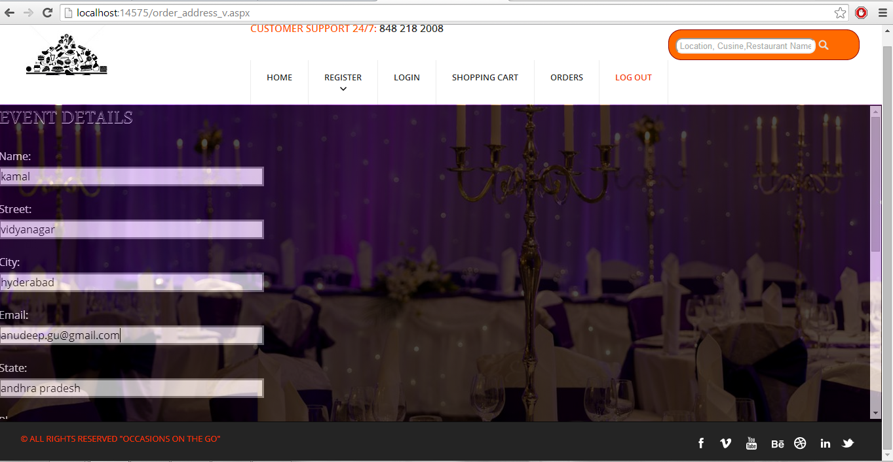

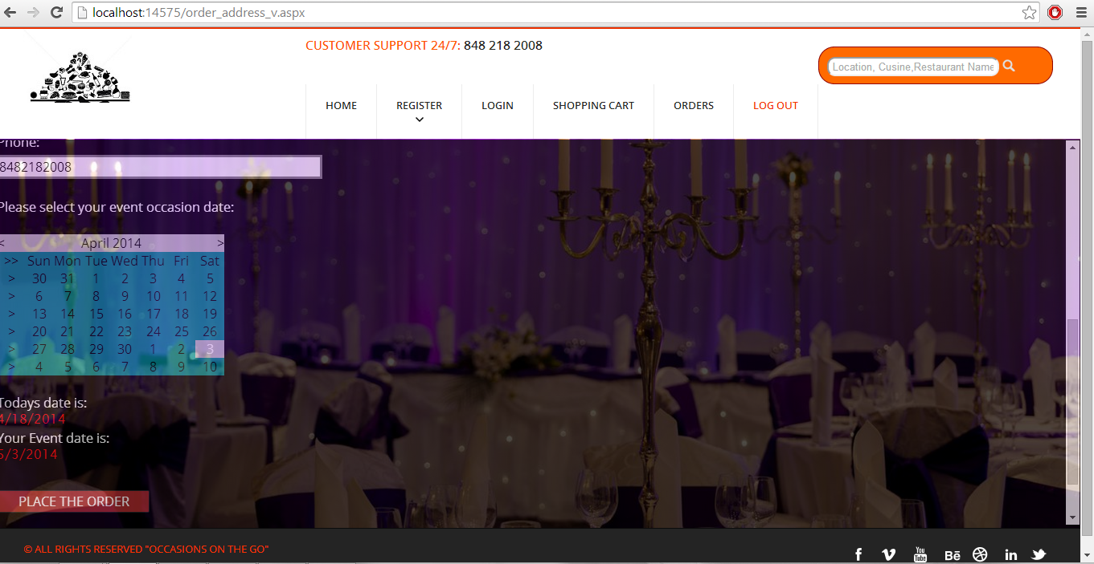

**Successful Completion Of Order:**

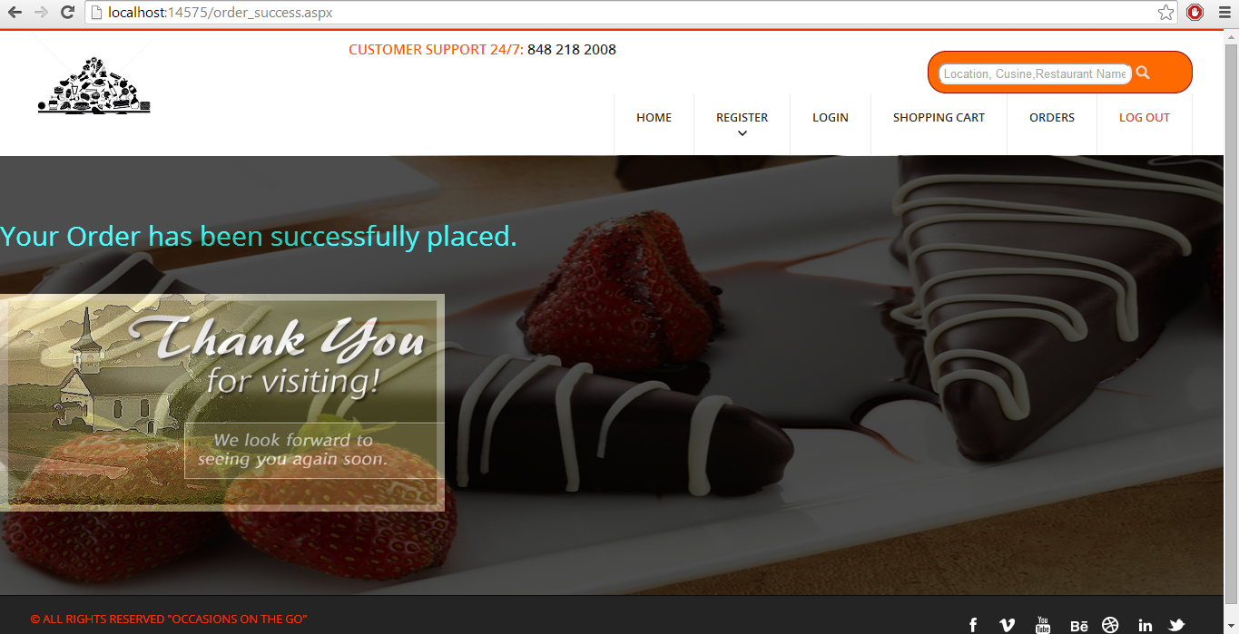

**Single Order Details for “JP Lighting Décor” shown in the above page:**

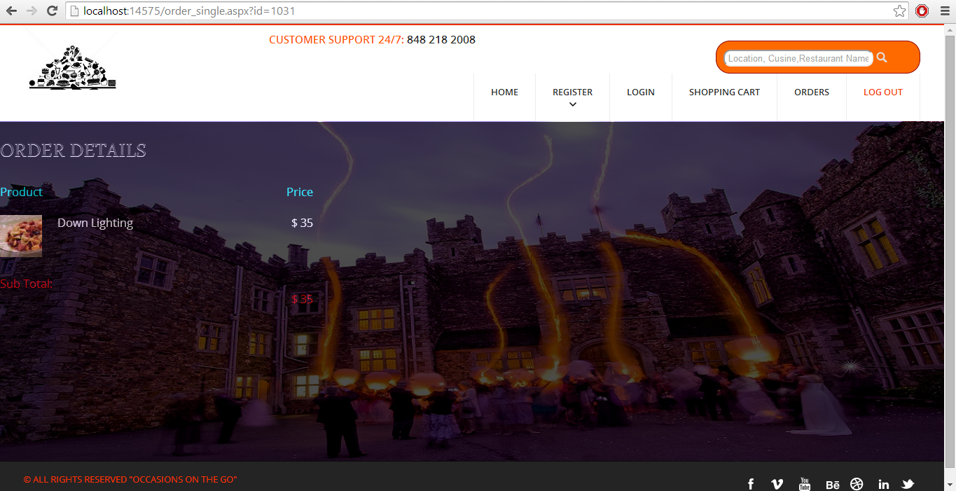

**Mail Confirmation:**

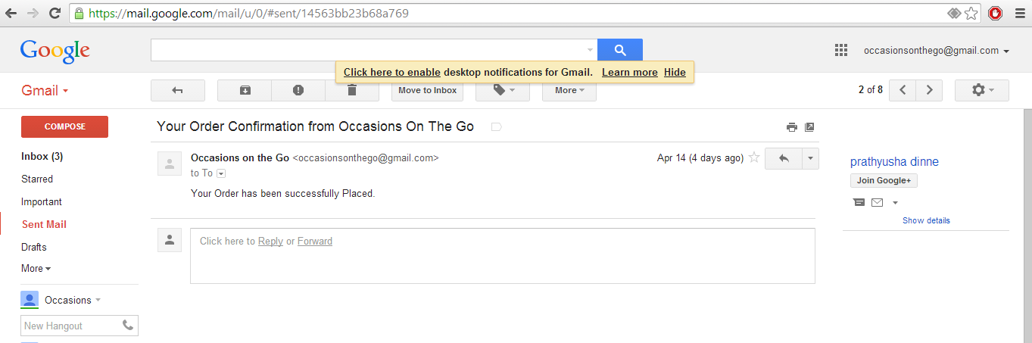

**User Order Page:**

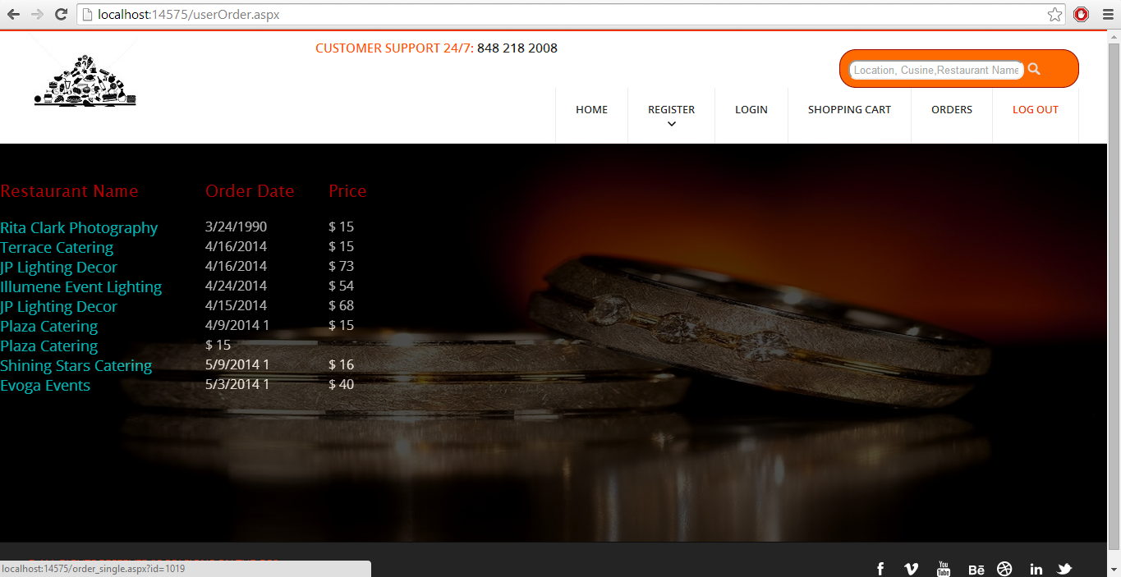

**Vendor Sales Graphical Representation Page:**

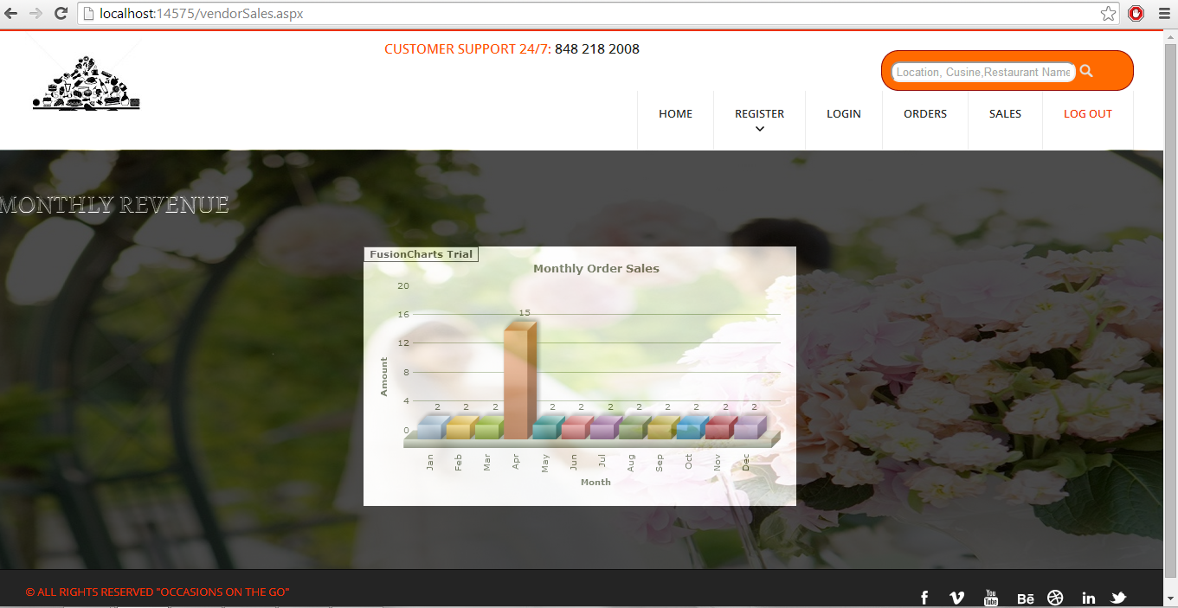

**Vendor View Of Orders from Different Customers:**

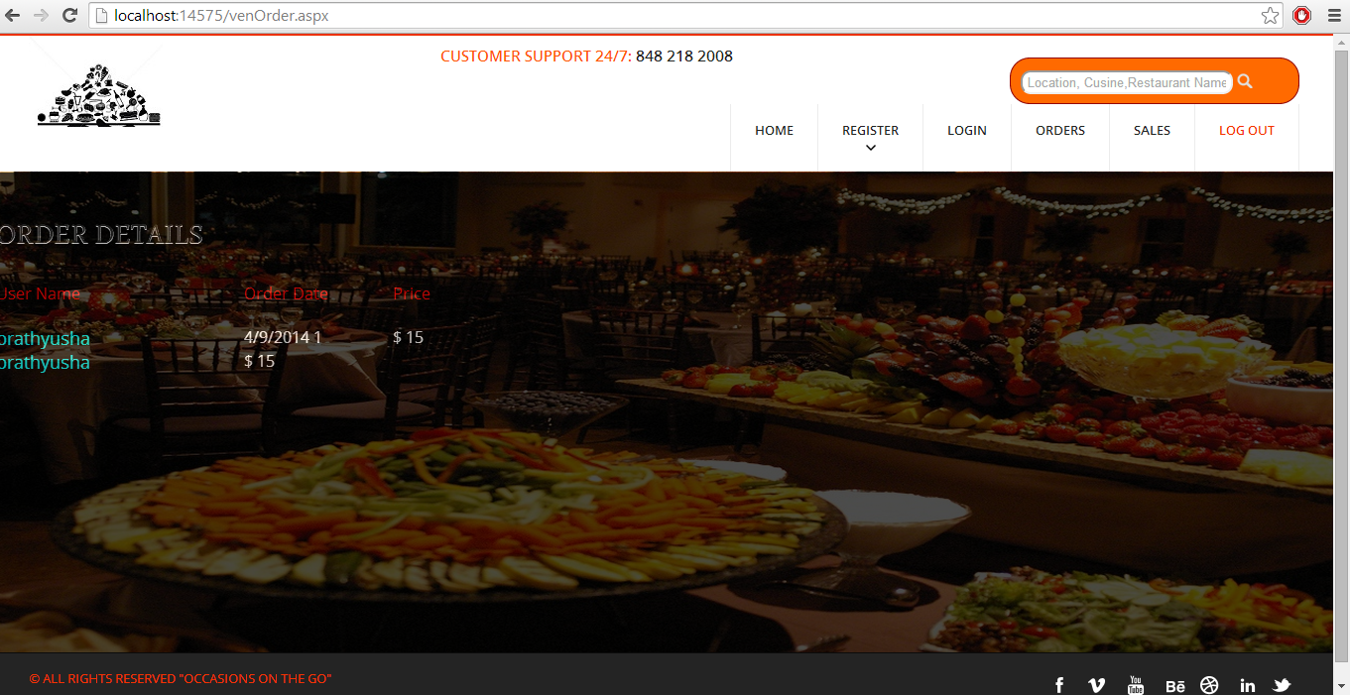

**Clicking On The User Vendor Can View Details Of The User’s Order:**

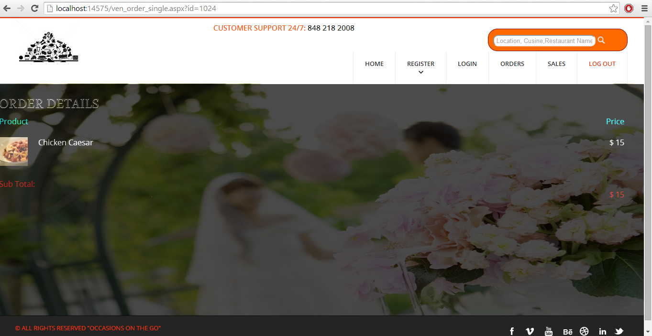

**Search Results Page:**

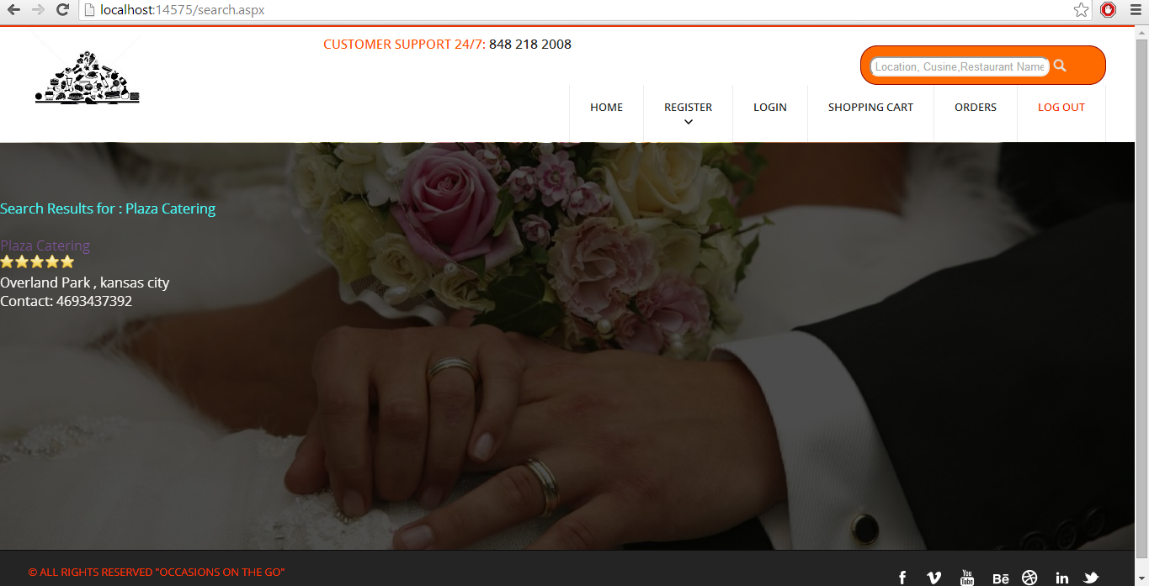

**Work Completed As Part Of 3rd Increment:**

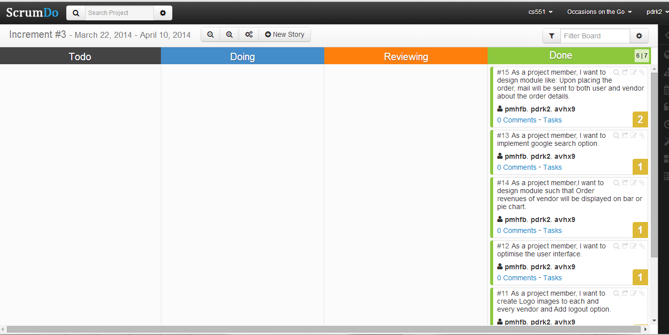

**Responsibilities:**

|  |  |  |  |
| --- | --- | --- | --- |
| **Sl.No** | **Task** | **Person involved** | **Estimated Time** |
| 1. | Upon placing the order, mail will be sent to both user and vendor about the order details. | Prathyusha  Anudeep | 8 hours |
| 2. | Order revenues of vendor will be displayed on bar or pie chart | Prathyusha  Anudeep  Poojitha | 6 hours |
| 3. | Implementing search engine option | Poojitha | 2 hours |
| 4. | Further enhancements to second increment have been implemented. | Prathyusha  Poojitha  Anudeep | 6 hours |
| 5. | Logo images have been inserted to each and every vendor. | Poojitha | 5 hours |
| 6. | Optimized the UI | Prathyusha | 2 hours |
| 7. | Testing | Anudeep | 2 hours |

**Work to be completed in 4th increment:**

**Responsibilities:**

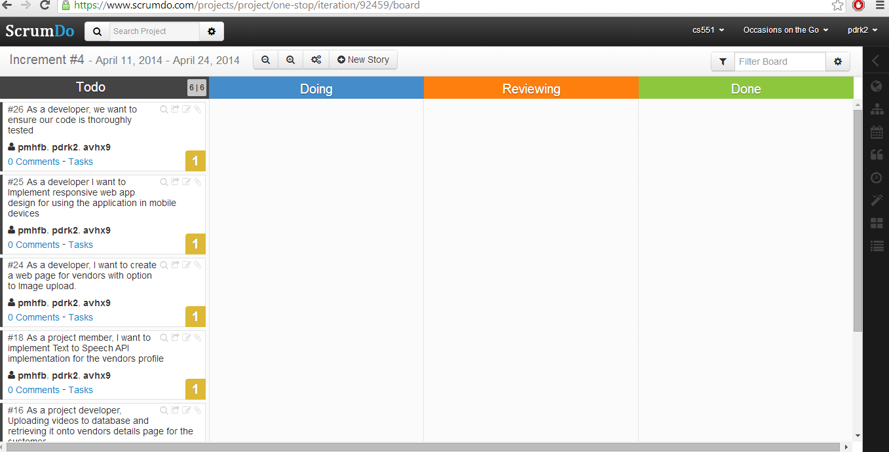

|  |  |  |
| --- | --- | --- |
| **Sl.No** | **Task** | **Person involved** |
| 1. | Text to Speech API implementation for the vendors profile | Prathyusha  Poojitha |
| 2. | Uploading videos to database and retrieving it onto vendors details page for the customer | Prathyusha  Anudeep |
| 3. | Integrating weather API to view weather updates on occasion date | Prathyusha  Poojitha |
| 4. | Image upload option for vendors. | Anudeep  Prathyusha |
| 5. | Implement responsive web app design for using the application in mobile devices | Prathyusha  Anudeep |
| 6. | Further addition of features which can be implemented | Prathyusha  Anudeep  Poojitha |
| 7. | Testing | Anudeep |
| 8. | Documentation | Prathyusha  Anudeep  Poojitha |

**Fourth Increment**

**Introduction:**

Planning an event is very simple and is on high demand. To plan an event, you need to select every vendor, login to their websites and order the required services. Also, it will be difficult to adapt to different patterns and designs as each vendor has their own in built design. To avoid these problems, our project acts as a single stop where in user can find different vendors in one place with a common user interface (UI). This project provides feasibility to order services both through mobile and web applications. In this application, both users and vendors can take advantage as user will be provided with best deals and vendor can attract customers by giving offers.

**Implementation Status Report:**

**Work Completed till 4th Increment:**

In fourth increment addition to what has been done in third increment, we have implemented online live chat communication between user and vendor as 24 * 7 service. Other features which we have developed include videos uploading, retrieving and displaying on each vendor’s page. Also, we have used weather API in our website through which user will have the option to check the weather on a particular date and in a particular location in order to schedule the event date accordingly. We have also designed text to speech API implementation where user upon clicking a button will be given all information about respective vendor. On the other hand, we have also made our website look with rich and simple UI design. The video production was also done for whole project/website.

* Text to speech API implementation in our website
* Online live chat communication between user and vendor
* Weather API integration
* Upload, retrieve and display videos for each vendor
* Rich and simple UI design
* Website video production

**Web Services:**

The webservices which we developed were:

1. Order details
2. Vendor menus
3. Item find
4. Login web services
5. Search engine

Order details web services have the following methods:

1. Adding user and vendor details respective to the order
2. Adding user order address details
3. User can view the orders
4. Vendor can view the orders

Vendor Menu and Item find webservice has the following methods:

1. Adding Menu items (for Catering and Theme Vendors )
2. Editing Menu items
3. Retrieval of menu items
4. Adding services for vendors (for Photography and Venue Vendors)
5. Editing services for vendors
6. Search results to display the searching item

**Order Details Table:**

This table consists of all queries Used for this table were:

a) insert into order_details (user_id,ven_id,details,total) values('" + user_id + "','" + ven_id + "','" + details + "','" + total + "');

b) UPDATE order_details SET email = '" + email + "', street = '" + street + "', city = '" + city + "', state = '" + state + "' , phone = '" + phone + "', date = '" + yDate + "' where id = '" + id + "'"

c) select * from order_details where ven_id = '" + ven_id + "'"

**Implementation of Services:**

Below services developed as part of this increment is:

1. Text to Speech Implementation
2. Weather API
3. Online live chat communication
4. Video retrieving and displaying for each vendor

As part of user interface, we have implemented sliding of images on the web pages for effective web page view.

**Screenshots of Web Application:**

**Retrieving and displaying videos for each vendor:**

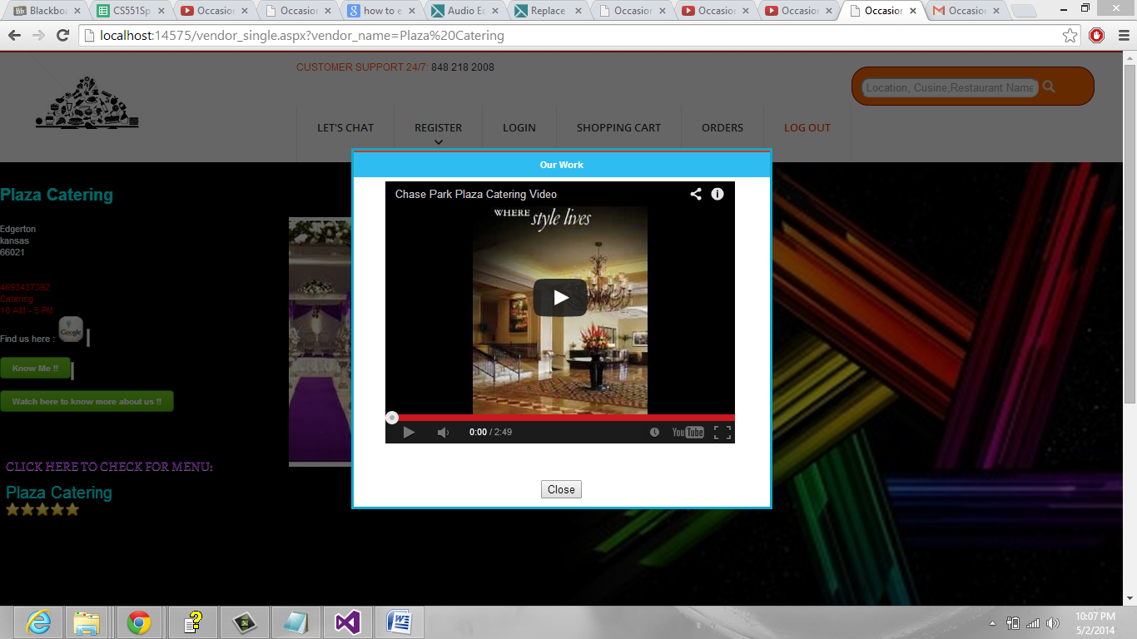

**Event Date can be selected and weather can be seen at a particular date and location before scheduling an event:**

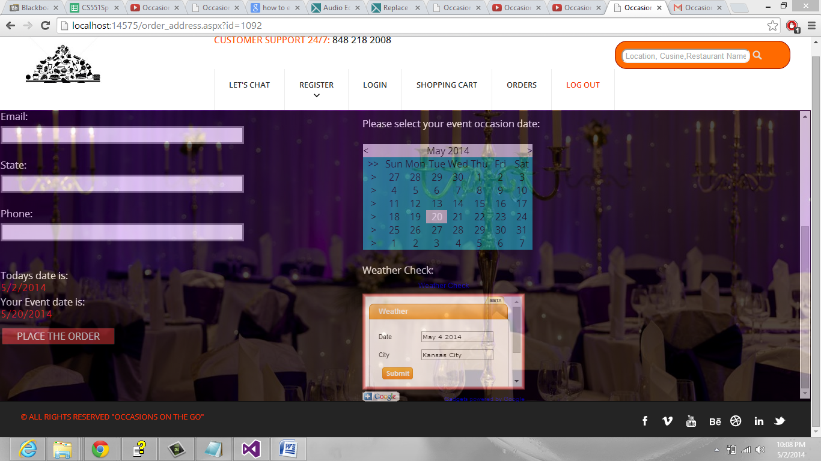

**Weather Check and Report:**

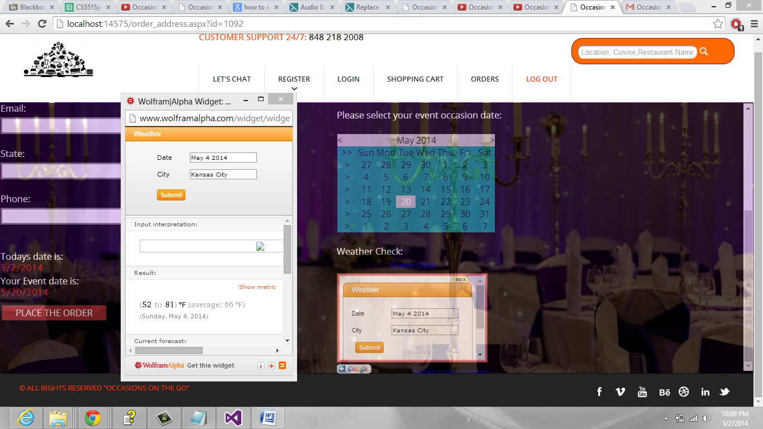

**Online Live chat communication between vendor and user:**

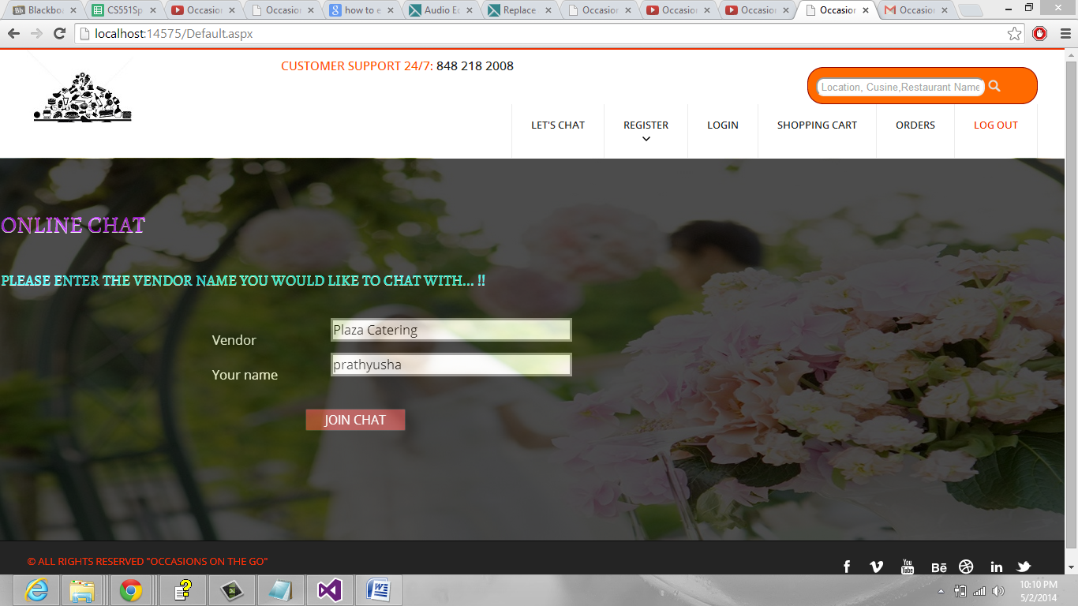

**Chat Window:**

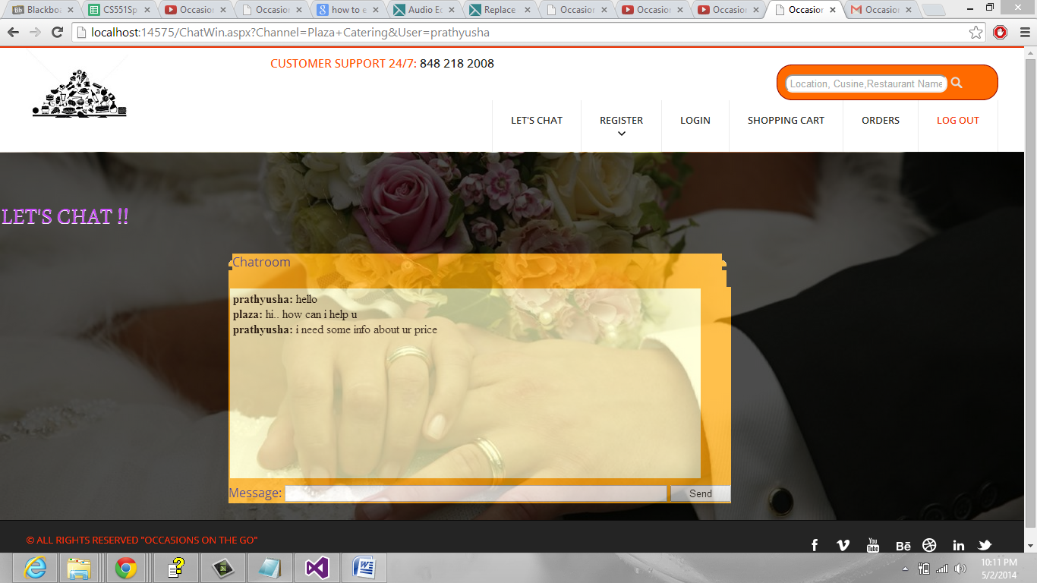

**Text to speech API implementation by clicking on know me button:**

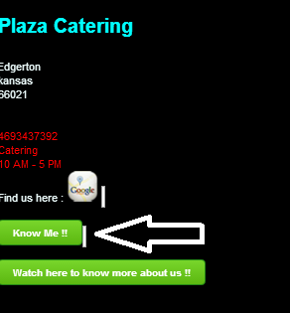

**Work completed in 4th increment:**

**Responsibilities:**

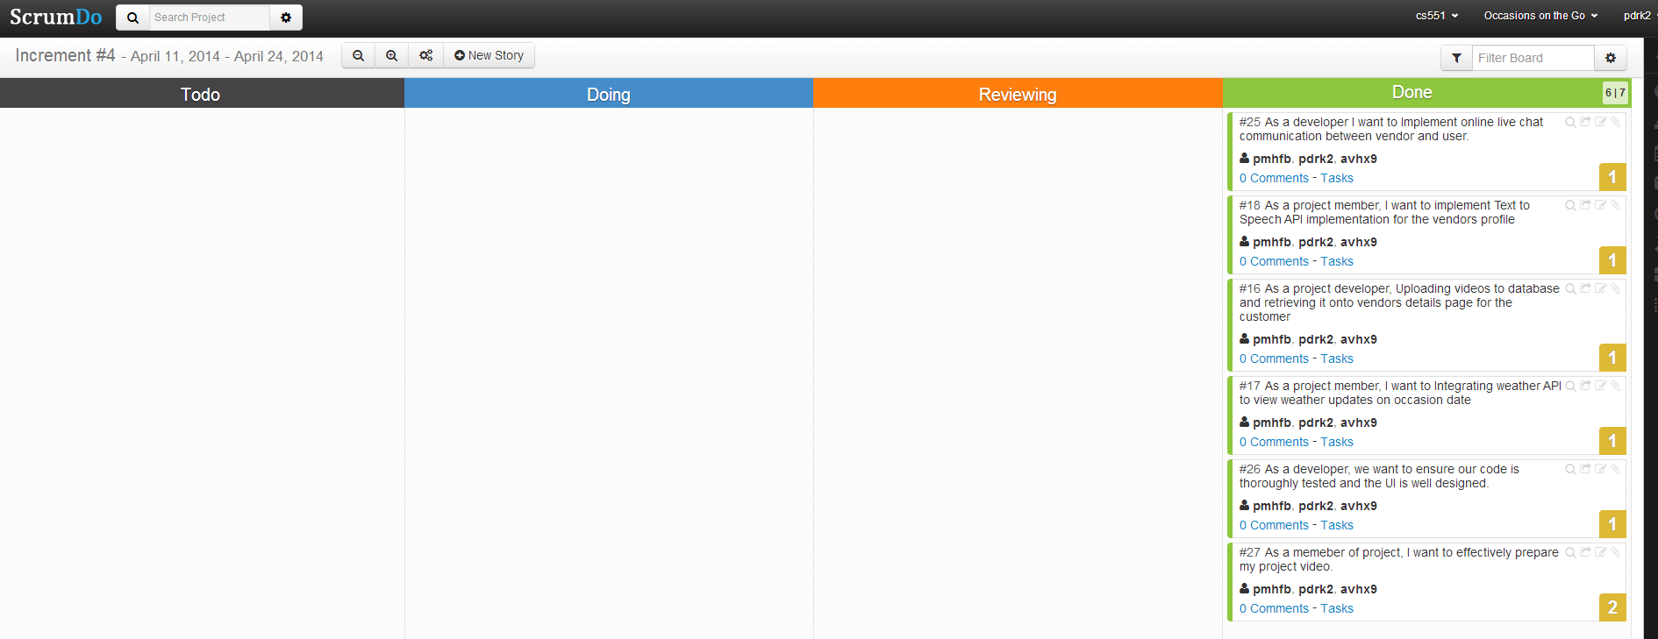

|  |  |  |
| --- | --- | --- |
| **Sl.No** | **Task** | **Person involved** |
| 1. | Text to Speech API implementation for the vendors profile | Prathyusha  Poojitha  Anudeep |
| 2. | Uploading videos to database and retrieving it onto vendors details page for the customer | Anudeep |
| 3. | Integrating weather API to view weather updates on occasion date | Poojitha |
| 4. | Online live chat communication between user and vendor | Prathyusha |
| 5. | User Interface Design &Testing | Anudeep  Prathyusha  Poojitha |
| 6. | Video production &Documentation | Prathyusha  Anudeep  Poojitha |

**User Manual**

**Git Hub Project URL:**

**https://github.com/pdrk2/Final_Project_Submission**

**1. Introduction:**

*Occasions on the Go* is an online based application that provides service to the customers in order to plan an event effectively. This application acts as a bridge between the users and the organizers in scheduling and conducting various events. It allows the customers to select any particular service that is available and suits the best for the occasion. The customers will be able to order the services from different vendors in the nearest locations.

**2. How to use the system:**

Our system supports only web version and any user can access our system by registering and logging in for free.

**2.1. How to access the system:**

The user will be directed to our home page “Occasions on the Go” upon opening our website. In the home screen user can find “Register as User, “Register as Vendor” and “Login” tabs on the top of the screen with some rich user interface design. Also, in the side bar user can have a look at our past works. We have also provided with contact information in order to reach us for any inconvenience or assistance.

**2.2. Registration and Login:**

Our system will provide two separate registration forms for customer and vendor. New members can fill their details and submit the forms to the system. If the user-entered details doesn’t meet any requirements it will prompt an error message, otherwise it will display successful registration upon clicking submit button in the registration form. Existing customer can use their credentials to login to the system. Customers and vendors login to the system separately. Upon successful login both the users will be redirected to their profile page. If they want to edit their profile, they can use edit button in the profile page.

**2.3 Search:**

In our system, we have used effective search mechanism. Customer can give location name, item name, zip code and vendor name as input to the search box. Search web service will retrieve the vendor details those meet the search requirements.

**2.4 Contact Us:**

On the top of the home page we have provided contact us tab. If any user wants to contact the system administrator they can leave a message to him/her by submitting the form in “ contact us” page.

**2.5 Vendor Screens:**

After successful authentication vendor user can see “Online live chat communication”,” Menu”, “Sales”, “Orders”.

1. **Online Live chat communication:** This link provides a medium for vendor to interact with customer at any point of time in need.
2. **Menu:** This tab displays the menu owned by the vendor. Even vendor user can add new menu item to the list and update the existing menu item list.
3. **Sales:** Upon clicking this button a graph will be displayed to the vendor user, where vendor can compare the vendor revenue in each month.
4. **Orders:** Orders page will display the abstract details of each order coming from the customers in a list view. By clicking any item in the list a detailed description will be shown containing order of items, data of delivery, price etc.

**2.6 Customer Screens:**

After successful authentication restaurant user can see “four different services”,” Online live chat communication”, “Orders”.

1. **Services:** This link provides the list of services “Occasions on the Go” system can serve. For example Catering, Photography, Venue, Theme etc. By selecting any service system will display the vendors those having the corresponding service type in their menu. By clicking any vendor name it will display the vendor details like address, office timings, etc. Below the vendor address there is a Google map indicator. This will help user to navigate to particular vendor. And also on the below of google map, customer is provided with a button “Know Me” where in upon clicking customer can listen to the description of respective vendor. It also provided with “Watch Us” button where in upon clicking this customer can have a look at respective vendor’s past work as a video. Each vendor is provided with menu and customer can select the items and add them to shopping cart accordingly.
2. **Online Live chat communication:** This link provides a medium for customer to interact with respective vendor at any point of time in need.
3. **Orders:** Orders page display the past history of the customer orders.

**2.7 Shopping cart:**

This page will be displayed only to the customer. User can add menu items to the shopping cart. User can find all the items he added to the shopping cart in “shopping cart” page and once he/she has done with his/her selection he/she can proceed to checkout. After clicking checkout system will ask for customer address, event time and date etc. Customers can select future dates also.

**2.8 Logout:**

Users can logout from the system using “Logout” tab.

**2.9 Social Sharing:**

In every page of the system, on the bottom left corner we have provided separate buttons for social sharing websites Facebook, twitter, LinkedIn, Google+ .Everyone can share our website on social networking sites by clicking any one of those.

**2.10 Mail Implementation:**

A mail will be generated and sent by our website “Occasions on the Go” to both customer and vendor upon successful order placement.

**2.11 Weather Forecast**

Customer is provided with weather prediction option where he/she can check for weather conditions for a particular date and place. This helps customer to schedule his/her event accordingly as per the weather report shown in our website i.e., if it’s a good day he schedules the event else he checks for another day.

**Final Project Evaluation**

As part of our project completion we would like to evaluate our system. Our main aim in taking up this project was to provide a single platform to customers in accessing different types of vendors like photography, venue, catering, and theme decorators and enable users/customer to easily navigate through all the services and choose amongst them. We were successful in implementing all of the services we initially gave a thought to.

Before we got into the development phase we got a clear picture about our design model by drawing UML diagrams for our system. This gave us a complete overview on how we need to proceed in each phase. We have used agile process model in developing our project. One great thing about picking up agile model is that every person involved in the project gets to work in it learning to accomplish tasks in scheduled time.

One thing we should always bear in mind is to maintain a clear cutting picture of how the output of each increment should be and design plans accordingly. Also in our future projects we would like to follow agile process model. As we followed this model and done each increment within a scheduled timeline, we never faced a problem. Everyone got involved in designing our project and so we were able to maintain timelines and deploy each increment as scheduled.

**Presentation Materials**



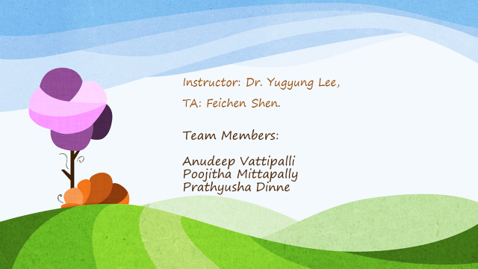

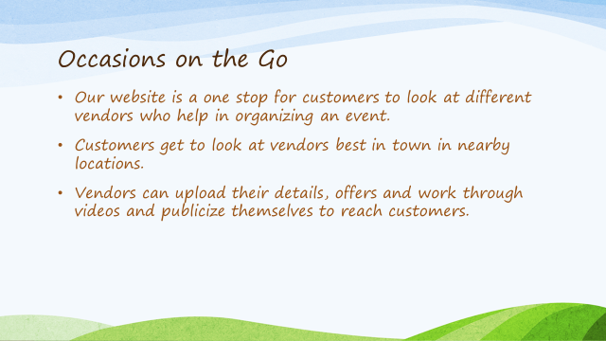

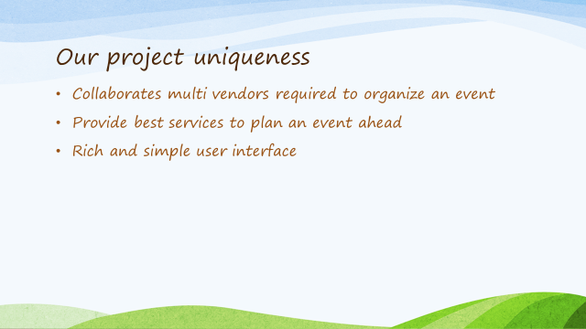

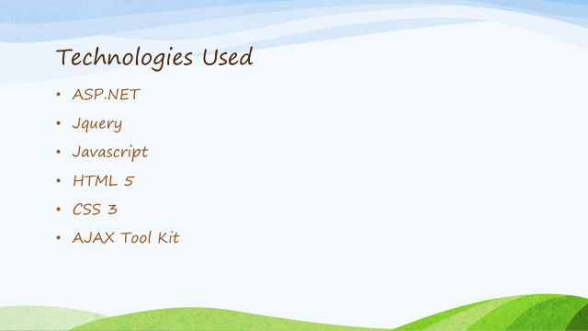

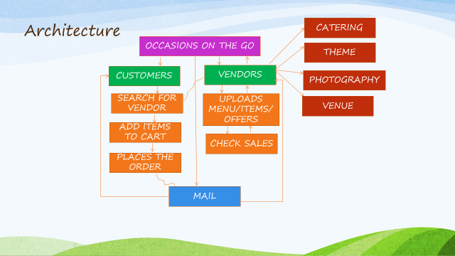

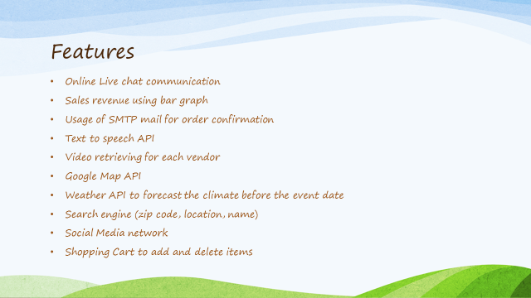







**References**

* [www.google.com](http://www.google.com)
* [www.codeprojects.com](http://www.codeprojects.com)
* [www.aspnetsnippets.com](http://www.aspnetsnippets.com)
* [www.stackoverflow.com](http://www.stackoverflow.com)
* [www.slideshare.net](http://www.slideshare.net)
* [www.w3schools.com](http://www.w3schools.com)
* [www.webtemplate.com](http://www.webtemplate.com)
* [www.freecsstemplates.com](http://www.freecsstemplates.com)
* [www.asp.net-tutorials.com](http://www.asp.net-tutorials.com)
* [www.microsoft.com/net](http://www.microsoft.com/net)